## Project Report

On

## SangLehar Gym Fitness Management System

Project work submitted in partial fulfilment of the requirement for the award of the degree.

## Bachelor of Computer Applications

By

**SANGITA RAWLO (107223504043)**

**LEHARIKA KAVALA (107223504014)**



**BHAVAN’s VIVEKANANDA COLLEGE OF SCIENCE, HUMANITIES & COMMERCE**

# SAINIKPURI, SECUNDERABAD – 500094

Re-Accredited with ‘A’ Grade by NAAC Autonomous College – Affiliated to Osmania University

3



# ACKNOWLMENT

Apart from the efforts of me, the success of any project depends largely on the encouragement and guidelines of many others. I take this opportunity to express my gratitude to the people who have been instrumental in the successful completion of the project.

Firstly, I would like to thank our Principal, **Dr.G.S.V.R.K. Choudary**, Bhavan’s Vivekananda College, for having faith in me and believing that I am capable enough to go on with the project.

Secondly, I would like to thank **Dr. N. Bhaskar**, Head of the Department of Computer Science, **Mr. G. Mahesh Kumar**, BCA Course Coordinator, and other faculty members for their help during my project completion in the college. I take it as a great privilege for having done the project for **Bhavan’s Vivekananda College Science, Humanities & Commerce, Sainikpuri**.

Finally, I would like to convey my profound gratitude to my project guide **Mrs. B Divya Rekha, Lecturer, Department of Computer Science** for giving me this project in the college and enabling me by her valuable guidance and support.

The guidance and support received from all the members who have contributed to this project, was vital for the success of the project. I am grateful for their constant support and help.

**SANGITA RAWLO (107223504043)**

**LEHARIKA KAVALA (107223504014)**

# DECLARATION

I hereby declare that the project work entitled **“SangLehar Gym Fitness Management System”** submitted to the Bhavan’s Vivekananda College, Sainikpuri, Secunderabad, is a record of an original work done by me under the guidance of

**Mrs. B Divya Rekha**, Lecturer, Department of Computer Science, Bhavan’s Vivekananda College, Sainikpuri, Secunderabad.

I further certify that the work has not been submitted to any other Institution for the award of any degree or diploma.

**SANGITA RAWLO (107223504043)**

**LEHARIKA KAVALA (107223504014)**

# ABOUT THE ORGANIZATION

Bhavan's Vivekananda College of Science, Humanities and Commerce was in 1993 under the aegis of the Bharatiy Vidya Bhavan. Ever since its inspection, the college has been providing quality education to all students in large variety of courses. The college continues to provide all students a solid foundation for further educational opportunities and the skill for various career opportunities upon graduation.

The college offers a peaceful atmosphere, which is ideal for academic pursuits and for the overall development of the students. The college seeks to integrate the student's program of study and the development of skills, which includes critical thinking, problem solving, written and oral communication and encouraging research techniques in various fields. It seeks to learn, to adapt and to lead in the creation of a pool of committed and competent individuals indicated to the process of nation building.

The college has a dedicated set of staff, lecturers, and support staff. The lecturers, apart from teaching, also imbibed in principles of discipline, commitment, and hard work and to strive towards achieving the goals. They support the students in all possible ways and help students to solve their various problems and encourage the students to perform well in both academics and other co-curricular activities. Overall, the college, with its holistic atmosphere aided for learning, the principles and values that are imbibed into the students, the excellent staff headed by an able and strong Principle dedicated to making students the citizens of the future, Bhavan's Vivekananda College of Science, Humanities and Commerce is the college, where we enter in as students and pass out as molded and well- read person, ready to take on the challenges that come by us in the future.

# INDEX

|  |  |  |
| --- | --- | --- |
| **S.No.** | **TOPIC** | **Page Number** |
| **1.** | **Abstract** | **6** |
| **2.** | **Problem Statement** | **7-8** |
| **3.** | **Proposed System** | **9** |
| **3.1** | **Overview & Goals** | **9** |
| **3.2** | **Modules** | **10-11** |
| **4.** | **System Requirement** | **12** |
| **4.1** | **Software Requirement** | **12** |
| **4.2** | **Hardware Requirement** | **12** |
| **5** | **Software Used** | **13-15** |
| **6** | **System Analysis** | **16** |
| **6.1** | **Entity-Relationship Diagram** | **16-23** |
| **6.2** | **Data Flow Diagram** | **23-25** |
| **7** | **System Design** | **26** |
| **7.1** | **Class Diagram** | **26-31** |
| **7.2** | **Activity Diagram** | **32-36** |
| **7.3** | **Use Case Diagram** | **37-38** |
| **7.4** | **Sequence Diagram** | **39-41** |
| **7.5** | **Deployment Diagram** | **41-43** |
| **8** | **Admin Screen** | **44-52** |
| **9** | **User Screen** | **53-62** |
| **10** | **Sample Code** | **63-81** |
| **11** | **Testing** | **82-83** |
| **12** | **Implementation** | **84** |
| **13** | **Maintenance** | **85** |
| **14** | **Conclusion** | **86** |
| **15** | **Bibliography** | **87** |

1. **ABSTRACT**

SangLehar Gym Fitness Management System is a web-based gym management system designed to automate and digitize traditional manual processes in fitness centers. The platform integrates various functionalities for administrators, trainers, members, and guests, streamlining gym operations, improving efficiency, and enhancing user experience. The system enables digital record-keeping, automated attendance tracking, online membership management, workout and diet planning, and an e-commerce module for purchasing gym-related products.

The primary objective of SangLehar Gym Fitness Management System is to transform gym management by reducing paperwork, improving data accessibility, and offering a structured system for handling memberships, payments, attendance, and fitness schedules. This digital solution enhances gym operations while providing members and trainers with tools to track progress and stay engaged in fitness routines.

The system is designed to cater to different user roles. Admins manage all operations, including users, trainers, memberships, payments, attendance, and product sales. Trainers oversee members' fitness routines, track progress, assign workouts and diet plans, and provide fitness resources. Members can track attendance, view workout plans, access training videos, and make purchases. Guests can explore the website and apply for gym membership online. The system addresses inefficiencies in the existing manual gym management model, providing a structured and efficient approach to handling fitness center activities.

SangLehar Gym Fitness Management System offers comprehensive functionalities. Admins have access to a dashboard where they can manage memberships, track trainer performance, handle payments, oversee gym product sales, and generate reports on attendance and transactions. Trainers can monitor both personal and member attendance, assign workout schedules and diet charts, and upload training videos. Members can manage their profiles, track attendance, access fitness schedules, shop for gym products, and provide feedback. Guests can browse the website and apply for membership.

The system is developed using Django 3.1 as the backend framework with MySQL 5.5 for database management. The frontend is built using HTML5, CSS 2.1, and JavaScript. Additional tools such as Microsoft PowerPoint, EDraw Max, and Microsoft Visio were used for documentation and design. The database structure includes modules for user management, membership tracking, trainer details, workout plans, payments, e-commerce, and attendance monitoring.

SangLehar Gym Fitness Management System introduces significant improvements over traditional gym management methods. It enhances efficiency by automating administrative tasks, reducing errors, and providing easy accessibility to records. Trainers and members benefit from remote access to attendance records, personalized workout and diet plans, and training resources. The integrated e-commerce feature enables members to purchase fitness products directly through the system. Reward points and training videos keep members engaged and motivated. The reporting and analytics module aids data-driven decision-making, providing valuable insights into gym performance and member engagement.

SangLehar Gym Fitness Management System is a robust gym management system that revolutionizes fitness center operations. By digitizing membership handling, attendance tracking, workout planning, and financial transactions, the platform offers a seamless experience for admins, trainers, and members alike. Its integration of fitness tracking and e-commerce capabilities further enhances the user experience, making it a comprehensive solution for modern gym management.

# PROBLEM STATEMENT

Traditional gym management systems rely heavily on manual processes, which lead to inefficiencies, data loss, and operational bottlenecks. Paper-based record-keeping makes it difficult to track member attendance, payment histories, and trainer schedules. The lack of an automated system also hinders gym members from accessing personalized fitness plans and progress reports efficiently. Without a centralized digital platform, gym owners struggle to manage trainer performance, membership renewals, and financial transactions effectively.

### Key Challenges:

**User Engagement and Experience –** Ensuring that members and trainers find the platform intuitive and engaging, reducing resistance to digital adoption. A user-friendly interface and seamless navigation are critical for effective utilization.

**Diversity in Course Offerings –** Customizing workout schedules and diet plans to meet the varying needs of members with different fitness goals. The system must accommodate diverse training programs, from weight loss to muscle gain and rehabilitation exercises.

**Seamless Data Integration –** Synchronizing attendance, payment records, and workout progress in real-time without data inconsistencies. The platform should allow smooth data exchange across different modules.

**Security and Privacy Concerns –** Protecting sensitive personal and financial data of members, trainers, and gym administrators. Implementing encryption and access control mechanisms is necessary to prevent data breaches.

**Scalability and Performance –** Ensuring the system can handle a growing number of users without performance degradation. The platform should efficiently process high volumes of concurrent transactions and interactions.

**Payment and Membership Handling –** Automating membership renewals, payment reminders, and ensuring secure online transactions. The system must integrate with reliable payment gateways and maintain accurate financial records.

**Trainer-Member Interaction –** Providing efficient communication channels between trainers and members for personalized training experiences. This includes messaging, virtual consultations, and interactive workout guidance.

**Technical Adoption and Training –** Assisting gym staff and members in adapting to the new digital system with minimal disruption. Proper training and onboarding support are essential for smooth implementation.

**Automated Reporting and Analytics –** Generating insightful reports on attendance, membership trends, trainer performance, and financial transactions. Advanced analytics can help gym owners make data-driven decisions.

# PROPOSED SYSTEM

### OVERVIEW and GOALS:

The **SangLehar Gym Fitness Management System** aims to digitalize gym management processes by creating an efficient, user-friendly, and automated platform. The system will streamline gym operations, improve member-trainer interactions, and enhance the overall user experience. It will integrate attendance tracking, workout schedules, payment processing, and online product sales into a single platform, making gym operations smoother and more organized.

* **Digital Transformation of Gym Operations:** Replacing traditional paper-based gym management with an automated digital system to enhance efficiency, reduce errors, and increase data accuracy.
* **Enhanced Member and Trainer Engagement:** Facilitating improved interactions between trainers and members by providing personalized workout plans, diet charts, progress tracking, and feedback mechanisms.
* **Automation of Attendance and Payment Tracking:** Implementing automated systems for attendance tracking and payment processing to reduce manual workload and ensure timely and accurate records.
* **Personalized Fitness Plans:** Providing members with tailored workout schedules and diet plans to meet their specific fitness goals, promoting higher engagement and better results.
* **Comprehensive Reporting and Analytics:** Equipping gym owners and administrators with powerful real-time reporting tools that help monitor gym operations, track performance, and make data-driven decisions for improvements.
* **Secure and Scalable System:** Designing a secure platform with robust encryption, authentication, and scalability to handle growing numbers of users, ensuring high performance without compromising data integrity or privacy.
* **Streamlined Membership and Payment Handling:** Simplifying membership management, renewals, and payment processing through automated reminders, secure online transactions, and detailed membership history.
* **Improved Trainer Productivity:** Allowing trainers to better manage their time and client interactions by automating scheduling, attendance tracking, and progress monitoring.
* **Seamless Product Management and Online Sales:** Enabling gym administrators to efficiently manage inventory, sell gym-related products online, and track product orders.
* **Integration of Communication Channels:** Providing easy-to-use messaging features for trainers and members, allowing for instant communication, virtual consultations, and sharing of workout advice or updates.
* **Increased User Accessibility:** Creating a platform that is accessible across devices (desktop, tablet, mobile) to ensure members, trainers, and administrators can interact with the system anytime, anywhere.
* **Engagement Through Social and Educational Content:** Offering members access to a variety of fitness-related blogs, videos, articles, and success stories to increase engagement and provide educational value.
* **Feedback and Continuous Improvement:** Incorporating a feedback system where members can provide reviews and suggestions about their gym experience, helping the gym continuously improve its services.
  1. **MODULES:**

The system is divided into various functional modules that together ensure seamless gym management, each catering to different roles within the gym (Admin, Trainer, Member, Guest). Below are the modules integrated with their respective entities:

**1. User Management Module**

This module manages user roles and ensures that users (Admin, Trainer, Member, Guest) can interact with the platform according to their access level.

* Admin Functionality: Admins can add, update, and delete user accounts, assign roles (Admin, Trainer, Member, Guest), and manage permissions.
* Trainer and Member Functionality: Trainers and members can create and manage their profiles, ensuring accurate personal details and preferences are stored.
* Guest Functionality: Guests can only register for the gym and apply for membership until they become members.

**2. Attendance Management Module**

This module is responsible for tracking and managing attendance for both trainers and members.

* Admin Functionality: Admin can view and manage attendance records for both trainers and members, ensuring accurate tracking.
* Trainer Functionality: Trainers can track their own attendance as well as their members' attendance to ensure engagement.
* Member Functionality: Members can view their attendance history to track their gym participation.

**3. Workout and Diet Module**

This module allows trainers to create and manage personalized workout schedules and diet plans for each member.

* Trainer Functionality: Trainers can assign workout schedules and diet charts to members, modifying them based on performance or progress.
* Member Functionality: Members can access their personalized workout and diet plans, adjust if allow by their trainers, and track their progress over time.

**4. Payment and Membership Module**

This module manages membership payments, plan renewals, and ensures secure online transactions.

* Admin Functionality: Admin can set up membership plans, manage payments, and track financial transactions.
* Member Functionality: Members can view and renew their membership plans, make payments securely, and manage their financial history.
* Guest Functionality: Guests can apply for membership and make payments as part of the registration process.

**5. Trainer Management Module**

This module allows trainers to manage their interactions with members, including creating fitness plans and tracking progress.

* Trainer Functionality: Trainers can track member progress, assign exercises, monitor performance, and adjust training plans.
* Admin Functionality: Admin can view trainer performance and ensure that trainers are managing member relationships efficiently.

**6. Product Management Module**

This module handles the gym's online store, enabling admins to manage products for sale and track inventory.

* Admin Functionality: Admin can add, update, and delete products such as supplements, apparel, and gym equipment in the online store.
* Member Functionality: Members can browse the online store, purchase products, and view transaction history.

**7. Feedback and Review Module**

This module allows users to provide feedback on trainers, workouts, and the overall gym experience.

* Member Functionality: Members can submit feedback and rate their trainers, workout plans, and the gym environment.
* Admin Functionality: Admin can view feedback reports to help improve the services offered by the gym.

**8. Reporting and Analytics Module**

This module generates reports and analytics for the gym admin to monitor operations, financial status, and overall performance.

* Admin Functionality: Admin can generate and view reports on attendance, payments, performance, and product sales.
* Trainer Functionality: Trainers can access performance data to track their progress and the success of their members' fitness journeys.

**9. Security Module**

This module ensures the safety and privacy of user data, implementing encryption and role-based access controls.

* Admin Functionality: Admin manages user authentication, permissions, and data security protocols.
* Trainer and Member Functionality: Trainers and members access the system securely with encrypted login credentials and sensitive data protection.

**10. Communication Module**

This module facilitates communication between trainers and members.

* Trainer Functionality: Trainers can interact with members through direct messaging, provide feedback, and answer questions.
* Member Functionality: Members can communicate with their trainers regarding workouts, diet plans, or any gym-related inquiries.

# SOFTWARE REQUIREMENTS:

The software requirements for SangLehar Gym Fitness Management Systemensure that the system is functional, secure, and capable of running effectively on various platforms. These requirements are categorized into operating systems, database management systems, web frameworks, programming languages, and additional tools.

**4.1 Software Requirements:**

1. **Operating System:**
   * Windows 10/11 (32-bit or 64-bit)  
     The system is compatible with modern Windows operating systems for local testing and development purposes.
   * Linux/Ubuntu (Preferred for Server Deployment)  
     The platform is also suitable for deployment on Linux-based systems (Ubuntu recommended for hosting and production environments).
   * macOS (for Developer Machines)  
     macOS is supported for developers working in a cross-platform environment.
2. **Web Browser:**
   * Google Chrome (Latest Version)
   * Mozilla Firefox (Latest Version)
   * Microsoft Edge (Latest Version)  
     These browsers are recommended for accessing the SangLehar Gym Fitness Management Systemweb application to ensure compatibility with modern web standards.
3. **Database Management System (DBMS):**
   * MySQL 5.5 or Higher  
     The database stores all the information, such as user details, attendance, payments, workout plans, and more. MySQL is used for its reliability, scalability, and performance.
4. **Programming Languages:**
   * Python 3.8 or Higher  
     Python is the primary programming language used for backend development and API integrations.
   * HTML5, CSS 3, JavaScript  
     These are the core languages for frontend web development. HTML and CSS are used for the structure and design, while JavaScript adds interactivity.
   * Django 3.1  
     Django is the web framework that facilitates rapid development of secure and maintainable websites. It is the backbone of the application’s structure, handling everything from URL routing to security and data management.
5. **Web Server:**
   * Apache (Preferred for Deployment)  
     Apache is recommended for hosting the application on a web server. It provides flexibility and scalability.
   * Nginx (Alternative Web Server)  
     Nginx can be used as an alternative to Apache for deployment, especially for handling higher loads and performance optimizations.
6. **Version Control System:**
   * Git  
     Git is used for version control to track changes to the application code and collaborate with other developers.
7. **Additional Tools:**
   * Microsoft PowerPoint 2019  
     Used for project presentations and documentation.
   * Microsoft Visio 2016  
     For creating diagrams and flowcharts for the project architecture and design.
   * Microsoft Word 2019  
     Used for project documentation, reporting, and technical writing.
   * EDraw Max 9.0  
     For designing flowcharts and system diagrams.
8. **Integrated Development Environment (IDE):**
   * PyCharm or Visual Studio Code  
     These are the recommended IDEs for Python and web development, offering features such as debugging, code completion, and version control integration.
9. **Payment Gateway Integration (for Online Transactions):**
   * PayPal API / Stripe API  
     These APIs are used to handle secure online payment processing for gym memberships and product purchases.
10. **Security Libraries:**
    * SSL/TLS Encryption  
      The use of SSL/TLS certificates ensures that the data between users and the server is encrypted for security.
    * Django Security Middleware  
      Built-in security features in Django such as CSRF protection, SQL injection prevention, and secure cookie handling.

**4.2 Hardware Requirements**

The hardware requirements for SangLehar Gym Fitness Management Systemensure that the platform can operate efficiently both during development and when deployed for production use.

**Recommended Hardware Requirements:**

1. **For Development and Testing:**
   * Processor:
     + Minimum: Intel i3 or equivalent
     + Recommended: Intel i5 or higher
   * RAM:
     + Minimum: 4 GB
     + Recommended: 8 GB or higher
   * Storage:
     + Minimum: 100 GB HDD/SSD
     + Recommended: SSD with 256 GB or higher for faster access and better performance.
   * Graphics Card:
     + A basic graphics card (integrated or discrete) will suffice, as the application is web-based and does not require heavy graphics processing.
2. **For Production Environment (Server Deployment):**
   * Processor:
     + Minimum: Quad-Core Processor (e.g., Intel Xeon or AMD Ryzen)
     + Recommended: Octa-Core Processor for handling a higher number of users and traffic.
   * RAM:
     + Minimum: 8 GB
     + Recommended: 16 GB or more for optimal performance with multiple concurrent users.
   * Storage:
     + Minimum: 500 GB SSD
     + Recommended: 1 TB SSD for faster data retrieval and to handle large datasets, particularly for storing workout plans, videos, and member data.
   * Network:
     + Minimum 1 Gbps internet connection for smooth communication between the web server, users, and other integrated services.
   * Backup Storage (optional):
     + Use an external backup server or cloud storage for database backups and other critical data. Services like AWS S3 or Google Cloud Storage are ideal for this purpose.
3. **For Hosting and Cloud Services (Optional):**
   * Cloud Provider:
     + Amazon Web Services (AWS), Google Cloud Platform (GCP), or Microsoft Azure can be used to host the application in a scalable and reliable cloud environment.
   * Compute Instance:
     + EC2 (AWS), Compute Engine (GCP), or Virtual Machines with sufficient resources based on the expected user load.
   * Storage:
     + Use cloud storage like AWS S3 or Google Cloud Storage to store static files, images, and workout videos.

# SOFTWARE USED

### The following software tools and technologies were used to develop the SangLehar Gym Fitness Management Systemgym management system. These tools ensure that the platform is efficient, secure, and scalable, enabling smooth operation for both gym administrators and users.

**1. Frontend Software:**

The frontend of the SangLehar Gym Fitness Management Systemsystem is responsible for delivering a seamless, interactive, and user-friendly experience. It is developed using standard web technologies to ensure compatibility across different browsers and devices.

* **HTML5**  
  HTML5 is used for structuring the web pages. It ensures semantic markup, better compatibility with multimedia content, and allows the creation of responsive layouts.
* **CSS3**  
  CSS3 is used for styling the web pages, including layout designs, color schemes, fonts, and responsiveness. It helps make the user interface visually appealing and ensures a smooth experience across all devices.
* **JavaScript_ES6** Higher)  
  JavaScript adds interactivity to the system, such as dynamic content updates, form validation, and user interactions without needing to refresh the page. It also supports asynchronous operations for features like real-time updates and notifications.
* **Bootstrap**_**5**  
  Bootstrap is a responsive frontend framework that allows quick styling and responsive design. It ensures that the application looks great on all screen sizes, from mobile devices to desktops, using its pre-built grid system and components.
* **jQuery**  
  jQuery is used for simplifying DOM manipulation, handling events, and making AJAX requests. It makes the code easier to write and maintain.

**2. Backend Software:**

The backend of the system manages business logic, data processing, security, and communication with the frontend. The backend is responsible for handling user authentication, database management, and API integrations.

* **Django_3.1_(Python_Framework)**Django is the primary framework for developing the backend of the system. It follows the Model-View-Template (MVT) architecture, which helps in building secure, scalable, and maintainable web applications. Django handles tasks such as URL routing, database queries, authentication, and session management.
* **Python_3.8**Python is the programming language used for backend logic. It provides a clean and readable syntax that is easy to work with, enabling rapid development of features and integrations.
* **MySQL_5.5**MySQL is used as the relational database management system (RDBMS) for storing and managing data such as user profiles, attendance records, payment details, and workout plans. It is known for its reliability and high-performance queries.
* **Django-REST-Framework_(Optional-for-API-Development)**For handling API requests, the Django REST Framework (DRF) can be used to build a RESTful API, enabling integration with mobile applications, external services, or other third-party tools.
* **Gunicorn**Gunicorn is a Python WSGI HTTP server that serves the Django application in production. It works well with the Nginx or Apache web servers and ensures the efficient handling of requests.
* **Celery-(Optional_for_Background_Tasks)**Celery is an asynchronous task queue used for handling background tasks such as sending emails, processing payments, or performing scheduled tasks like generating reports.
* **Redis-(Optional_for_Caching)**Redis is an in-memory data store that can be used in conjunction with Django to cache frequently accessed data, improve performance, and reduce database load.

**3. Database Software:**

* **MySQL-5.5**The MySQL database is used for storing all the critical data for the application, such as user profiles, attendance, workout plans, membership details, and product information. MySQL's relational database management system provides consistency, reliability, and scalability for the platform.

**4. Development and Version Control Tools:**

* **Git**Git is used for version control to track changes in the application code and collaborate with multiple developers. It allows branching, merging, and easy management of different versions of the project.
* **GitHub**A remote repository platform like GitHub, GitLab, or Bitbucket is used to host the Git repository and provide collaboration tools for developers, including code review, pull requests, and issue tracking.

**5. Additional Tools:**

* **Postman Testing)**Postman is used for testing the APIs during development and ensuring that the endpoints function correctly.
* **Visual_Studio_Code**Visual Studio Code and PyCharm are IDEs used for backend and frontend development. They offer features like code completion, debugging, and version control integration.
* **Docker**Docker can be used for creating containerized environments, ensuring that the application runs consistently across various platforms and environments (development, staging, production).

**6. Payment Gateway Integration:**

* **PayPal_API-or-Stripe_API**For handling secure online payments, PayPal or Stripe APIs are used. These APIs allow users to make payments for memberships and products securely.

# SYSTEM ANALYSIS

* 1. **ENTITY-RELATIONSHIP DIAGRAM**

An Entity Relationship Diagram (ERD) is a visual representation of different entities within a system and how they relate to each other. They are widely used to design relational databases. The entities in the ER schema become tables, attributes and converted the database schema. Entity relationship diagrams are used in software engineering during the planning stages of the software project. They help to identify different system elements and their relationships with each other.

Entity-Relationship Diagram (ERD) Symbols and Notations:

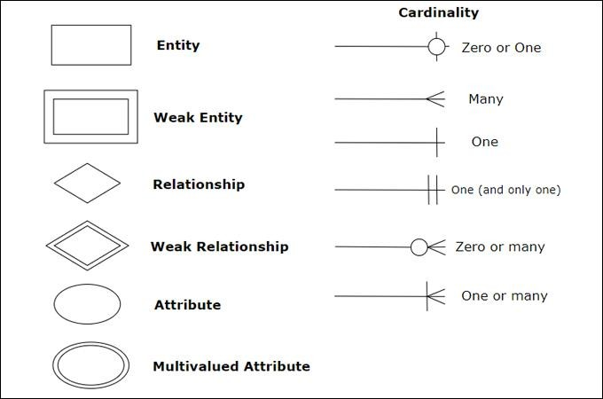

Elements in ER diagrams have three basic elements: entity, attribute, relationship. There are more elements that are based on the main elements. They are weak entity, multi valued attribute, derived attribute, weak relationship, and recursive relationship. Cardinality and ordinality are two other notations used in ER diagrams to further define relationships.

### Entity

An entity can be a person, place, event, or object that is relevant to a given system.For example, a school system may include students, teachers, major courses, subjects, fees, and other items. Entities are represented in ER diagrams by a rectangle and named using singular nouns.

### Weak Entity

A weak entity is an entity that depends on the existence of another entity. In termsthat are more technical it can be defined as an entity that cannot be identified by its own attributes. It uses a foreign key combined with its attributed to form the primary key. An entity like order item is a good example for this. The order item will be meaningless without an order so it depends on the existence of the order.

**Entities and Their Descriptions**

**1. User_Type (User Classification)**

* **Primary Key:** TYPE_ID
* **Attributes:**
  + USER_TYPE – Specifies the role of the user in the system (Admin, Trainer, Member, or Guest).
* **Relationships:**
  + **One-to-Many** with User_Master: Each user type (e.g., Admin, Trainer) can have multiple users associated with it.

**2. User_Master (User Information)**

* **Primary Key:** User_Id
* **Attributes:**
  + Type_Id – References User_Type to define whether the user is an admin, trainer, or member.
  + User_Name, Gender, Email, Password, Address, Mobile, Photo, Id_Proof – Stores personal details of the user.
* **Relationships:**
  + **One-to-One** with Trainer_Details: If the user is a trainer, additional trainer-specific details are stored.
  + **One-to-Many** with Membership_Master: A user can have one or multiple memberships over time.
  + **One-to-Many** with Attendance_Master: A user can have multiple attendance records.
  + **One-to-Many** with Workout_Master: A user can have multiple workout schedules assigned.
  + **One-to-Many** with Order_Master: Users can place multiple product orders.
  + **One-to-Many** with Feedback_Master: Users can submit multiple feedback entries.

**3. Membership_Master (Membership Details)**

* **Primary Key:** Membership_Id
* **Foreign Keys:** User_Id, Plan_Id
* **Attributes:**
  + Start_Date, End_Date – Specifies membership validity.
  + Amount – Cost of the membership.
  + Details – Extra membership-related information.
  + Membership_Status – Active or Expired status.
* **Relationships:**
  + **One-to-One** with User_Master: Each member has a unique membership.
  + **Many-to-One** with Plan_Master: Multiple members can subscribe to the same plan.
  + **One-to-One** with Payment_Master: Each membership is linked to a specific payment.

**4. Plan_Master (Membership Plan Options)**

* **Primary Key:** Plan_Id
* **Attributes:**
  + Title, Details, Price, Duration – Defines various membership plans.
* **Relationships:**
  + **One-to-Many** with Membership_Master: A single plan can have multiple memberships.

**5. Trainer_Details (Trainer-Specific Information)**

* **Primary Key:** Trainer_Id
* **Foreign Key:** User_Id
* **Attributes:**
  + Salary, Details – Additional details about the trainer’s employment.
* **Relationships:**
  + **One-to-One** with User_Master: Each trainer is a registered user in the system.

**6. Workout_Master (Workout Schedules & Plans)**

* **Primary Key:** Workout_Id
* **Foreign Key:** User_Id
* **Attributes:**
  + Diet_Chart – Diet plan assigned to a user.
  + Workout_Schedule – List of exercises.
  + Videos – Training videos uploaded by trainers.
  + Rewards – Performance-based rewards for members.
* **Relationships:**
  + **One-to-Many** with User_Master: A user can have multiple workout schedules.

**7. Payment_Master (Payment Transactions)**

* **Primary Key:** Payment_Id
* **Foreign Key:** Membership_Id
* **Attributes:**
  + Amount, Method, Transaction_No, Payment_Receipt, Payment_Status – Stores financial transaction details.
* **Relationships:**
  + **One-to-One** with Membership_Master: Each membership has an associated payment.

**8. Product_Master (Gym Products for Sale)**

* **Primary Key:** Product_Id
* **Attributes:**
  + Product_Name, Qty, Details, Price, Product_Image – Information about gym-related products.
* **Relationships:**
  + **One-to-Many** with Order_Details: A product can be part of multiple orders.

**9. Order_Master (Customer Orders)**

* **Primary Key:** Order_Id
* **Foreign Key:** User_Id
* **Attributes:**
  + Ord_Date, Delivery_Date, Delivery_Status – Order processing details.
* **Relationships:**
  + **One-to-Many** with Order_Details: Each order contains multiple products.
  + **One-to-One** with User_Master: Each order is placed by a user.

**10. Order_Details (Items within an Order)**

* **Primary Key:** Details_Id
* **Foreign Keys:** Order_Id, Product_Id
* **Attributes:**
  + Qty, Price, Tot_Amt – Quantity and price details for each ordered product.
* **Relationships:**
  + **Many-to-One** with Order_Master: Each order can have multiple products.
  + **Many-to-One** with Product_Master: Each order detail refers to a specific product.

**11. Attendance_Master (Attendance Tracking)**

* **Primary Key:** Attendance_Id
* **Foreign Key:** User_Id
* **Attributes:**
  + A_Date, Time_In, Time_Out – Tracks daily check-ins and check-outs.
* **Relationships:**
  + **One-to-Many** with User_Master: Each user can have multiple attendance records.

**12. Feedback_Master (User Reviews and Ratings)**

* **Primary Key:** Feedback_Id
* **Foreign Key:** User_Id
* **Attributes:**
  + Details, Ratings – Stores user feedback.
* **Relationships:**
  + **One-to-Many** with User_Master: A user can submit multiple feedback entries.

**Relationships Between Entities**

* **User_Type ↔ User_Master** *(One-to-Many)* – A single user type (Admin, Trainer, Member) can have multiple users.
* **User_Master ↔ Membership_Master** *(One-to-One)* – Each member is linked to a unique membership.
* **Membership_Master ↔ Plan_Master** *(Many-to-One)* – Multiple memberships can be part of a single plan.
* **Membership_Master ↔ Payment_Master** *(One-to-One)* – Each membership has a corresponding payment transaction.
* **User_Master ↔ Trainer_Details** *(One-to-One)* – A trainer is a user with additional attributes.
* **User_Master ↔ Workout_Master** *(One-to-Many)* – A user can have multiple workout schedules assigned.
* **User_Master ↔ Attendance_Master** *(One-to-Many)* – A user can have multiple attendance records.
* **User_Master ↔ Order_Master** *(One-to-Many)* – A user can place multiple orders.
* **Order_Master ↔ Order_Details** *(One-to-Many)* – Each order contains multiple products.
* **Order_Details ↔ Product_Master** *(Many-to-One)* – Each order detail is linked to a specific product.
* **User_Master ↔ Feedback_Master** *(One-to-Many)* – Users can submit multiple feedback entries.

The **ER diagram** effectively structures the database by organizing data and defining clear relationships between different entities. This well-defined schema ensures smooth operations in the **SangLehar Gym Fitness Management System**system, covering user management, membership handling, trainer assignments, payment processing, order management, attendance tracking, and feedback collection. The system's architecture minimizes data redundancy, improves efficiency, and provides a robust framework for managing a gym digitally.

**ENTITY-RELATIONSHIP DIAGRAM FOR ENIGMAEDU:**

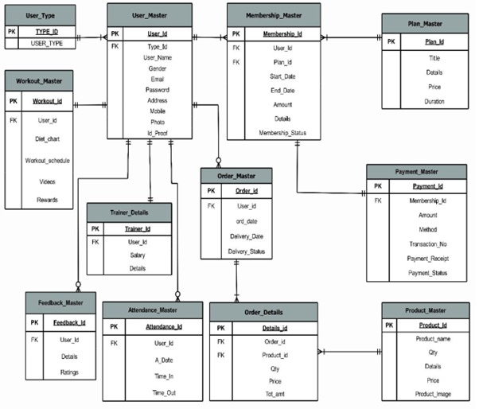

# DATA - FLOW DIAGRAM

* DFD is the abbreviation for Data Flow Diagram. The flow of data of a system or a process is represented by DFD. It also gives insight into the inputs and outputs of each entity and the process itself. DFD does not have control flow and no loops or decision rules are present. Specific operations depending on the type of data can be explained by a flowchart. Data Flow Diagram can be represented in several ways. The DFD belongs to structured-analysis modelingtools. Data Flow diagrams are very popular because they help us to visualize the major steps and data involved in software-system processes.
* A full description of a system actually consists of a set of data flow diagrams. Using two familiar notations Yourdon, Gane, and Sarson notation develops the data flow diagrams. Each component in a DFD is labeled with a descriptive name.

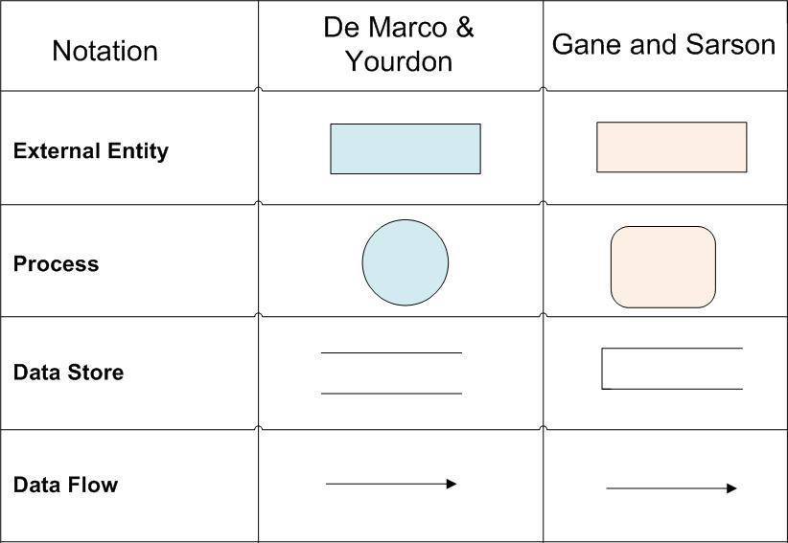

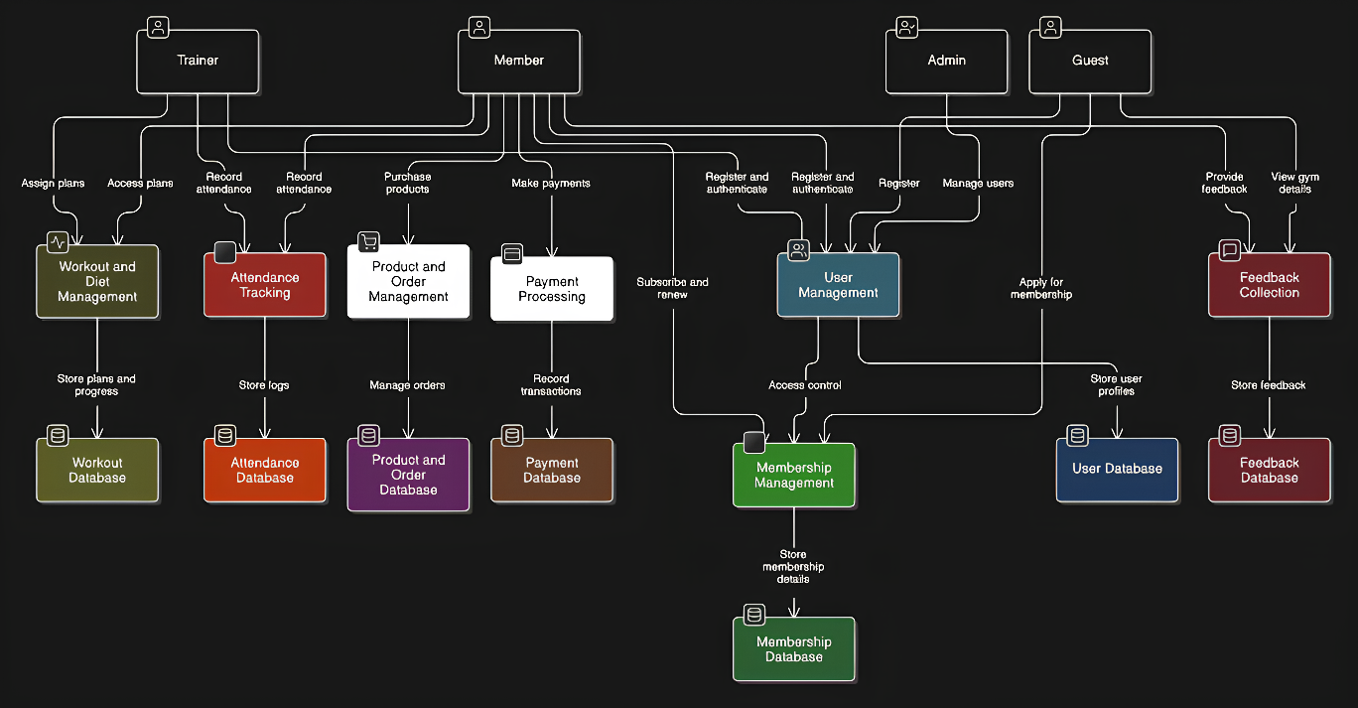**DATA - FLOW DIAGRAM LEVEL-0**

**DATA - FLOW DIAGRAM LEVEL 1**

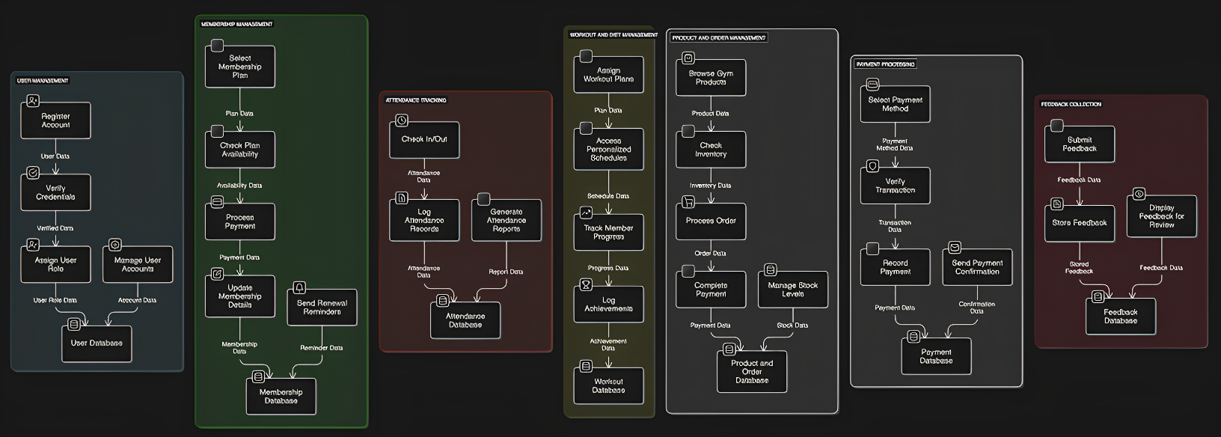

# UML DIAGRAMS

UML stands for Unified Modeling Language. This object-oriented system of notation has evolved from the work of Grady Brooch, James Rumbaugh, lvar Jacobson and the rational software corporation. These renowned computer scientists fused their respective technologies into a single, standardized model. Today, the Object Management Group (OMG) as the standard for modeling object-oriented concepts. The unified modeling notation that is governed by a set of syntactic semantic and pragmatic rules. A UML system is represented using five different views that describe the system from a distinctly different perspective. Each view is defined by a set of diagrams, which is as follows.

Types of UML Diagram we drew in this project are:

* Class Diagram
* Activity Diagram
* Use Case Diagram
* Sequence Diagram
* Component Diagram
* Deployment Diagram
* Collaboration Diagram
  1. **CLASS DIAGRAM**

The UML Class diagram is a graphical notation used to construct and visualize object- oriented systems. A class diagram in the Unified Modelling Language (UML) is a type of static structure diagram that describes the structure of a system by showing the systems:

* Classes
* their attributes,
* operations (or methods),
* and the relationships among objects.

**Class:** A Class is a blueprint for an object. Objects and classes go hand in hand. We cannot talk about one without talking about the other. In addition, the entire point of Object-Oriented Design is not about objects, it is about classes, because we use classes to create objects. Therefore, a class describes what an object will be, but it is not the object itself.

**UML Class Notation:** A class represents a concept, which encapsulates state (attributes) and behaviour (operations). Each attribute has a type. Each operation has a signature. The class name is the only mandatory information.

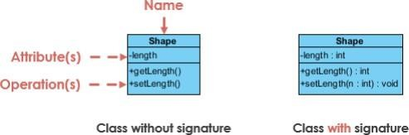

**Class Name:** The name of the class appears in the first partition.

### Class Attributes:

* Attributes are shown in the second partition.
* The attribute type is shown after the colon.
* Attributes map onto member variables (data members) in code.

### Class Operations (Methods):

* Operations are shown in the third partition. They are services the classprovides.
* The return type of a method is shown after the colon at the end of the method signature.
* The return type of method parameters are shown after the colon following the parameter name.
* Operations map onto class methods in code.

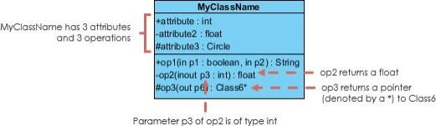

Class Visibility, the + , - and # symbols before an attribute and operation name in a class denote the visibility of the attribute and operation.

+ denotes public attributes or operations

- denotes private attributes or operations

# denotes protected attributes or operations.

### Relationships between classes:

**Inheritance (or Generalization):**

A generalization is a relationship between a more general classifier and a more specific classifier. Each instance of the specific classifier is also an indirect instance of the general classifier. Thus, the specific classifier inherits the featuresof the more general classifier. The figure below shows an example of inheritance hierarchy. SubClass1 and SubClass2 are derived from Superclass. The relationshipis displayed as a solid line with a hollow arrowhead that points from the child element to the parent element.

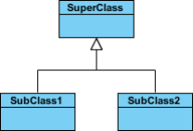

### Association:

Associations are relationships between classes in a UML Class Diagram. A solid line between classes represents them. Associations are typically named using a verb or verb phrase, which reflects the real world problem domain.

### Simple Association

* A structural link between two peer classes.
* There is an association between Class1 and Class2

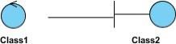

### Cardinality:

Cardinality is expressed in terms of:

* one to one
* one to many
* many to many

### Aggregation

* A special type of association.
* It represents a "part of'' relationship.
* Class2 is part ofClass1.
* Many instances (denoted by the *) of Class2 can be associated with Class1.
* Objects of Class1 and Class2 have separate lifetimes.

The figure below shows an example of aggregation. The relationship is displayed as a solid line with an unfilled diamond at the association end, which is connected to the class that represents the aggregate.

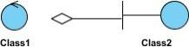

### Composition

* A special type of aggregation where parts are destroyed when the whole is destroyed.
* Objects of Class2 live and die with Class1.
* Class2 cannot stand by itself.

The figure below shows an example of composition. The relationship is displayed as a solid line with a filled diamond at the association end, which is connected to the class that represents the whole or composite.

### Dependency

* An object of one class might use an object of another class in the code of a method.
* If the object is not stored in any field, then this is modeled as a dependency relationship.
* A special type of association.
* Exists between two classes if changes to the definition of one may cause changes to the other (but not the other way around).
* Class1 depends on Class2.

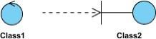

### Realization:

Realization is a relationship between the blueprint class and the object containing its respective implementation level details. This object is said to realize the blueprint class. In other words, you can understand this as the relationship between the interface and the implementing class. For example, the Owner interface might specify methods for acquiring property and disposing of property. The Person and Corporation classes need to implement these methods, possibly in very different ways.

**CLASS DIAGRAM :**

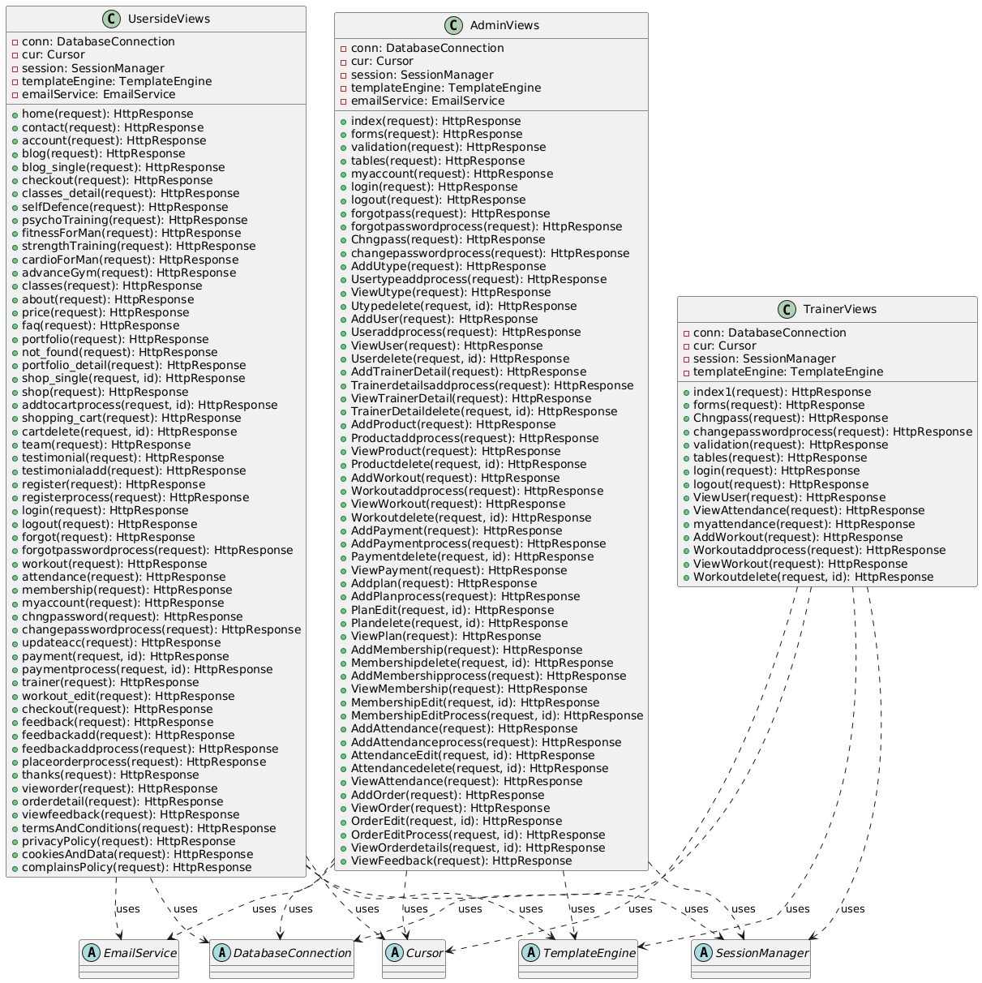

* 1. **ACTIVITY DIAGRAM**

Activity diagram is another important diagram in UML to describe the dynamic aspects of the system. Activity diagram is basically a flowchart to represent the flow from one activity to another activity. The activity can be described as an operation of the system. The control flow is drawn from one operation to another. This flow can be sequential, branched, or concurrent. Activity diagrams deal with all type of flow control by using different elements such as fork, join, etc. Purpose of Activity Diagrams: The basic purpose of activity diagrams is similar to other four diagrams. It captures the dynamic behaviour of the system. Other four diagrams are used to show the message flow from one object to another but the activity of the diagram is used to show the message flow from one activity to another. Activity is a particular operation of the system. Activity diagrams are not only used for visualizing the dynamic nature of a system, but they are also used to construct the executable system by using forward and reverse engineering techniques. The only missing thing in the activity diagram is the message part.

The purpose of an activity diagram can be described as-

* Draw the activity flow of a system.
* Describe the sequence from one activity to another.
* Describe the parallel, branched and concurrent flow of the system.

**Components of an Activity Diagram:** -

1. **Initial State or Start Point:** A small filled circle followed by an arrowrepresents the initial action state or the start point for any activity diagram.

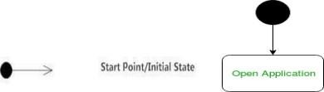

1. **Activities:** The categorization of behavior into one or more actions is termed as an activity. In other words, it can be said that an activity is a network of nodes that are 26 connected by edges. The edges depict the flowof execution. It may contain action nodes, control nodes, or object nodes. The control flow of activity is represented by control nodes and object nodes that illustrate the objects used within an activity. The activities are initiated at the initial node and are terminated at the final node.
2. 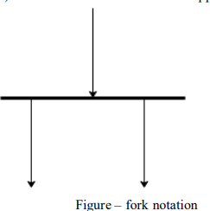**Fork** – Fork nodes are used to support concurrent activities.

When we use a fork node when both the activities get executed concurrently i.e., no decision is made before splitting the activity into twoparts. Both parts need to be. We use a rounded solid rectangular bar to represent a Fork notation with incoming arrows from the parent activity state and outgoing arrows towards the newly created activities. For example: In the example below, the activity of making coffee can be split into two concurrent activities and hence we use the fork notation.

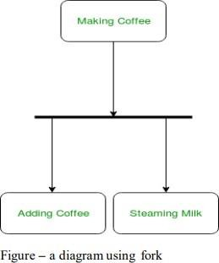

1. **Join** - Join nodes are used to support concurrent activities converging intoone. For join notations, we have two or more incoming edges and one outgoing edge.

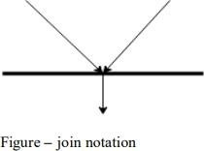

For example – When both activities i.e. steaming the milk and addingcoffee get completed, we converge them into one final activity.

1. **Action Flow** - Action flows, also called edges and paths, illustrate the transitions from one action state to another. They are usually drawn with an arrowed line.



1. **Decisions and Branching** - When we need to make a decision before deciding the flow of control, we use the decision node.

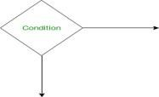

The outgoing arrows from the decision node can be labeled with conditionsor guard expressions. It always includes two or more output arrows.

1. **Guards** - A Guard refers to a statement written next to a decision node onan arrow sometimes within square brackets.

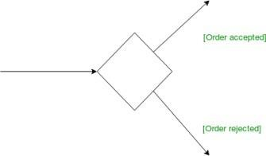

1. **Final State or End Point -** An arrow pointing to a filled circle nestedinside another circle represents the final action state.

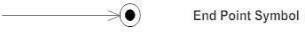

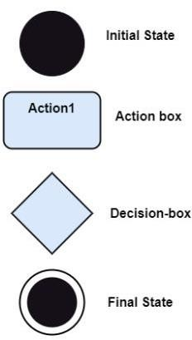

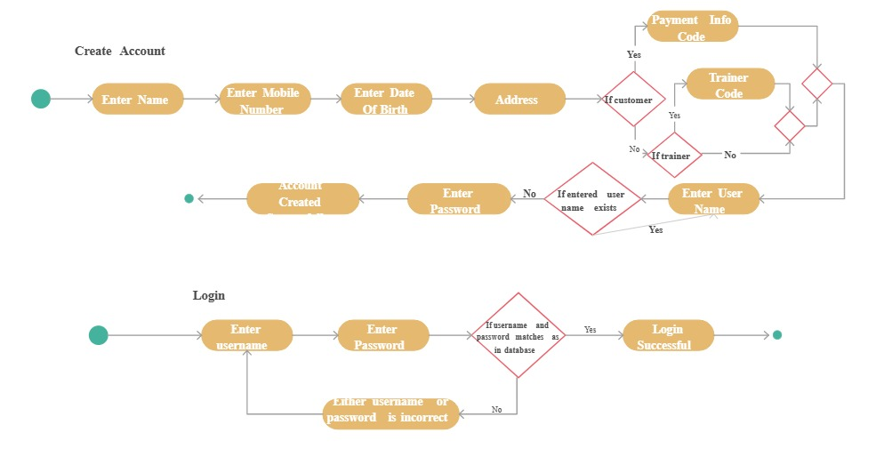**ACTIVITY DIAGRAM:**

* 1. **USE CASE DIAGRAM**

In Unified Modelling Language (UML), use case diagrams are used to show the interactions between actors and a system. The system can be a website or another similar entity being developed. An actor is a person or entity that interacts with the system - normally, this is a user. In essence, use case diagrams depict the system, who is using it, how they are using it, or what they are doing. On a macro scale, the information you can glean from use case diagrams allow you to set the scope of your system or application and what goals it can help the actors achieve.

### Use case diagrams are typically used in the following scenarios:

* Depicting the scope and goal of the interactions between the actor and thesystem.
* Modeling the interactions between actors and the system, as well as the generalflow of events.
* Identifying internal or external factors that might influence the outcome of interaction and, by extension, the system itself.

### Use Case Diagram Symbols:

The notation for a use case diagram is straightforward and does not involve as many types of symbols as other UML diagrams.

* **Use cases:** Horizontally shaped ovals that represent the different uses that auser might have.
* **Actors:** Stick figures that represent the people actually employing the usecases.
* **Relationship:** A line between actors and use cases. In complex diagrams, it is important to know which actors are associated with which use cases.

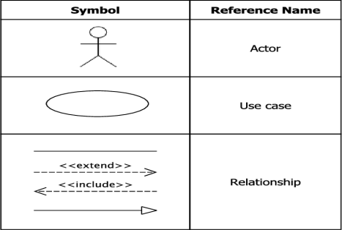

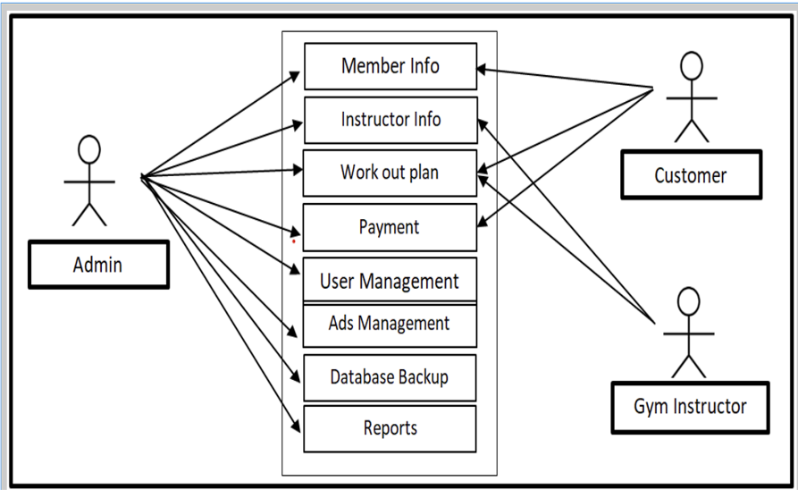**USECASE DIAGRAM:**

* 1. **SEQUENCE DIAGRAM**

Sequence diagrams describe interactions among classes in terms of an exchange of messages over time. They are also called event diagrams. A sequence diagram is a good way to visualize and validate various runtime scenarios. These can help to predict how a system will behave and to discover responsibilities a class may need to have in the process of modelling a new system.

### Basic Sequence Diagram Notations:-

* **Actor symbol:** Shows entities that interact with or are external to the system.



* **Activation:** Activation boxes represent the time an object needs to complete atask. When an object is busy executing a process or waiting for a reply message, use a thin grey rectangle placed vertically on its lifeline.

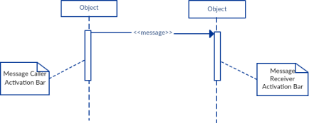

* **Messages:** Messages are arrows that represent communication between objects. We use half-arrowed lines to represent asynchronous messages. Asynchronous messages are sent from an object that will not wait for a response from the receiver before continuing its tasks.
* **Return:** A return message is used to indicate that the message receiver is done processing the message and is returning control over to the message caller. Return messages are optional notation pieces, for an activation bar that is triggered by a synchronous message always implies a return message.

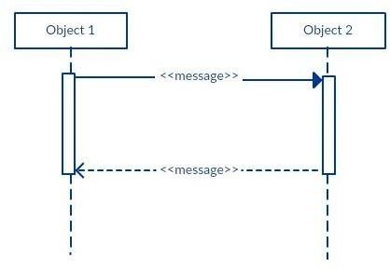

* **Lifelines:** Lifelines are vertical dashed lines that indicate the object's presence over time.
* **Comment:** UML diagrams generally permit the annotation of comments in all UML diagram types. The comment object is a rectangle with a folded-over corner as shown below. The comment can be linked to the related object witha dashed line.

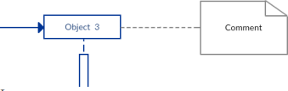

**SEQUENCE DIAGRAM:**

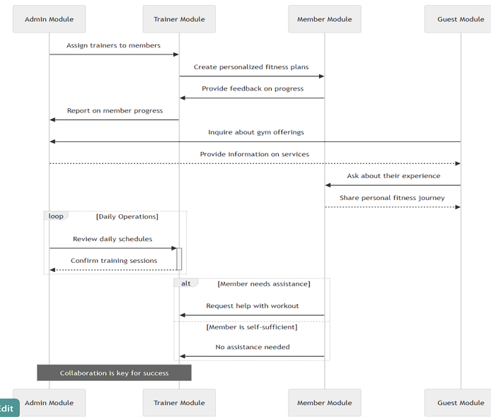

* 1. **DEPLOYMENT DIAGRAM**

A deployment diagram is a UML diagram type that shows the execution architecture of a system, including nodes such as hardware or software execution environments, and the middleware connecting them. Deployment diagrams are typically used to visualize the physical hardware and software of a system. Using it you can understand how the system will be physically deployed on the hardware. Deployment diagrams help model the hardware topology of a system compared to other UML diagram types, which mostly outline the logical components of a system.

Deployment Diagram Notations: In order to draw a deployment diagram, you need to first become familiar with the following deployment diagram notations and deployment diagram elements.

* 1. **Nodes:** A node, represented as a cube, is a physical entity that executes one ormore components, subsystems or executables. A node could be a hardware or software element.
  2. **Artifacts:** Artifacts are concrete elements that are caused by a development process. Examples of artifacts are libraries, archives, configuration files,executable files etc.
  3. **Communication Association:** This is represented by a solid line between twonodes. It shows the path of communication between nodes.
  4. **Devices:** A device is a node that is used to represent a physical computational resource in a system. An example of a device is an application server.
  5. **Deployment Specifications:** Deployment specifications is a configuration file, such as a text file or an XML document. It describes how an artifact is deployed.

**DEPLOYMENT DIAGRAM:**

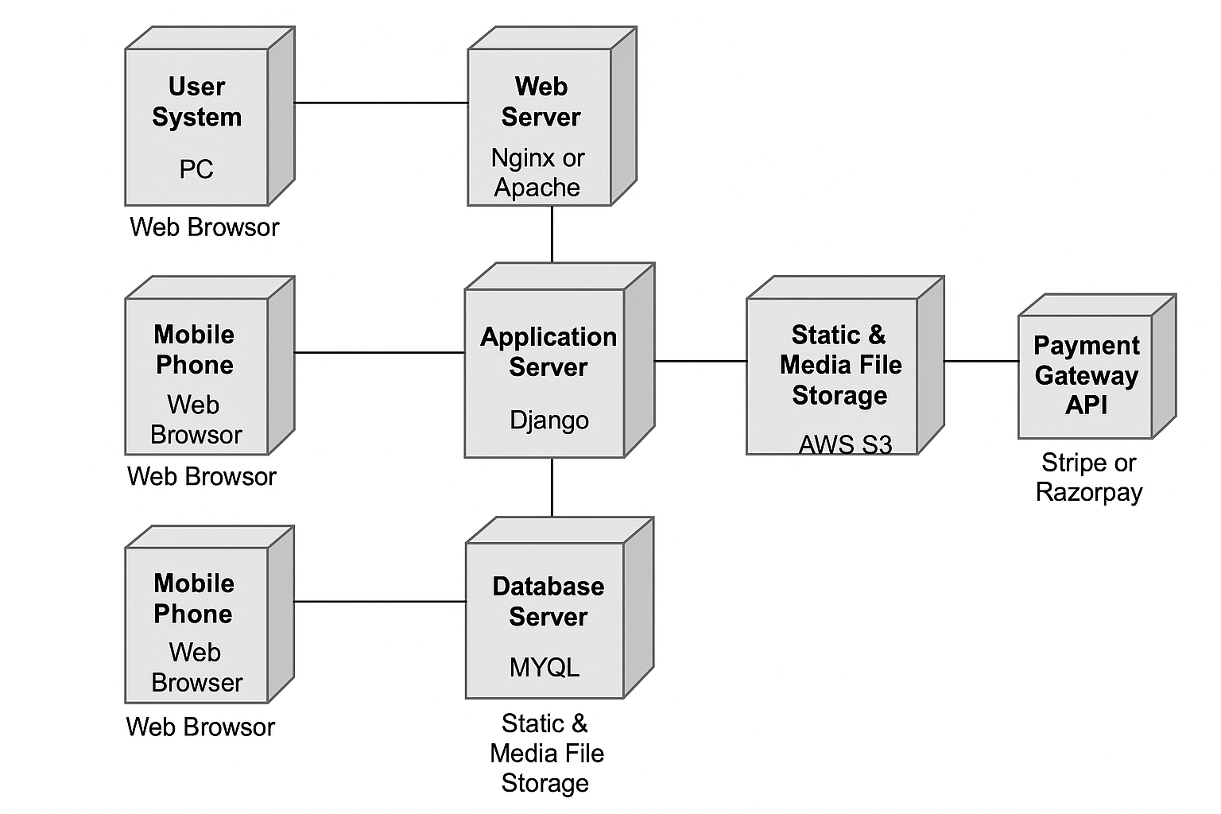

# ADMIN SCREEN(HYGRAPH)

### HYGRAPH Schema Models: Course:

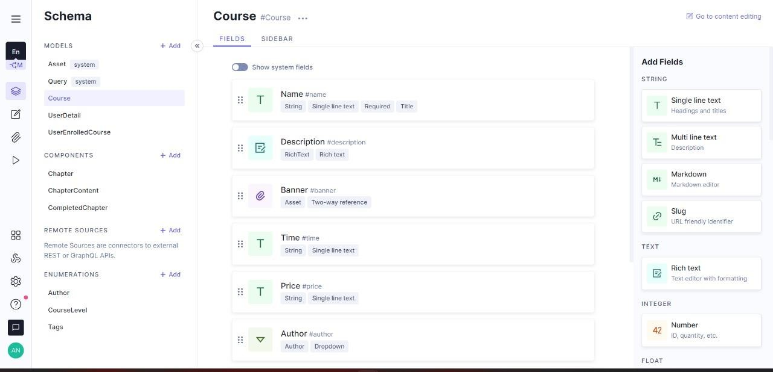

**UserDetails:**

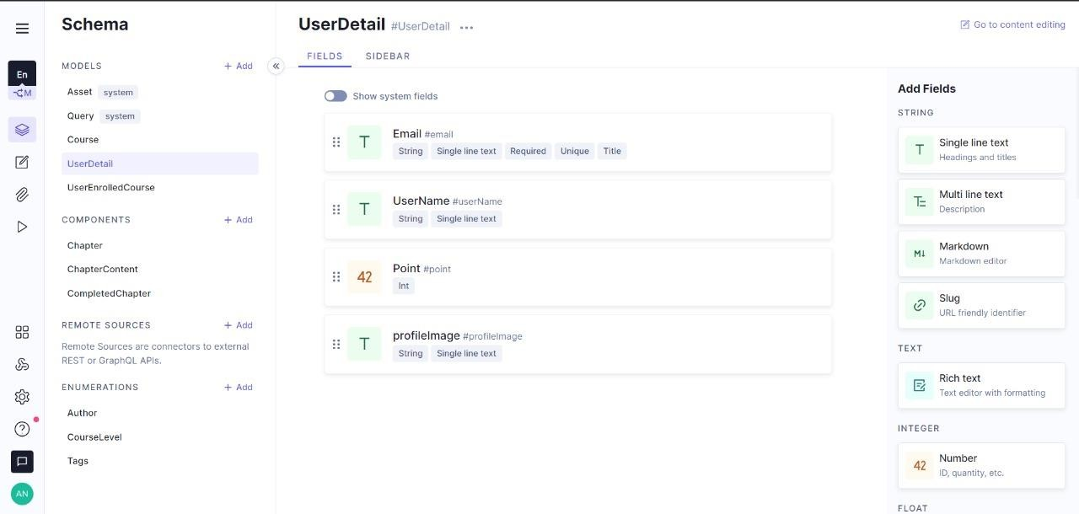

### UserEnrolledCourse:

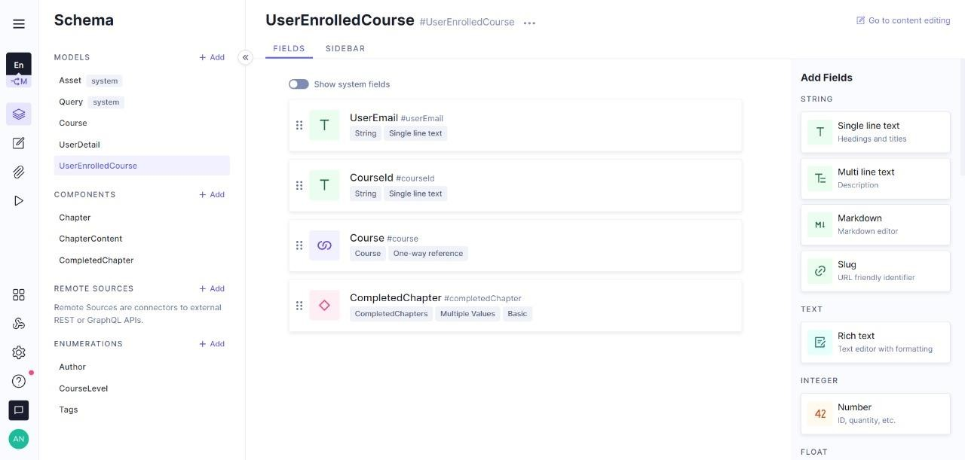

**Components:**

**Chapter:**

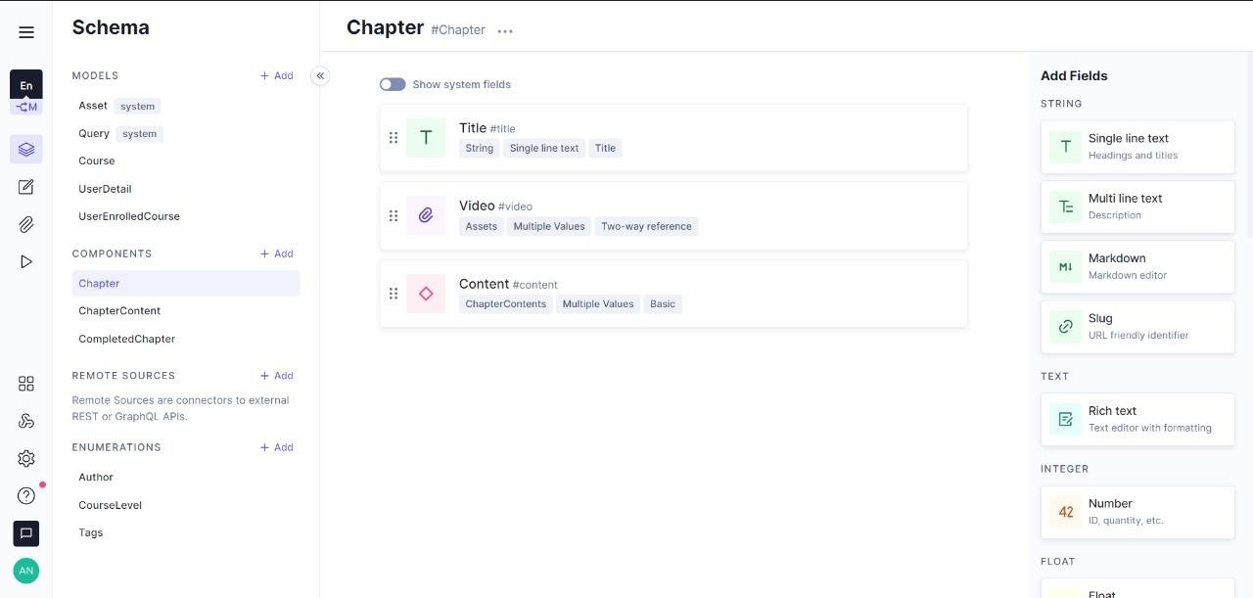

**Chaptercontent:**

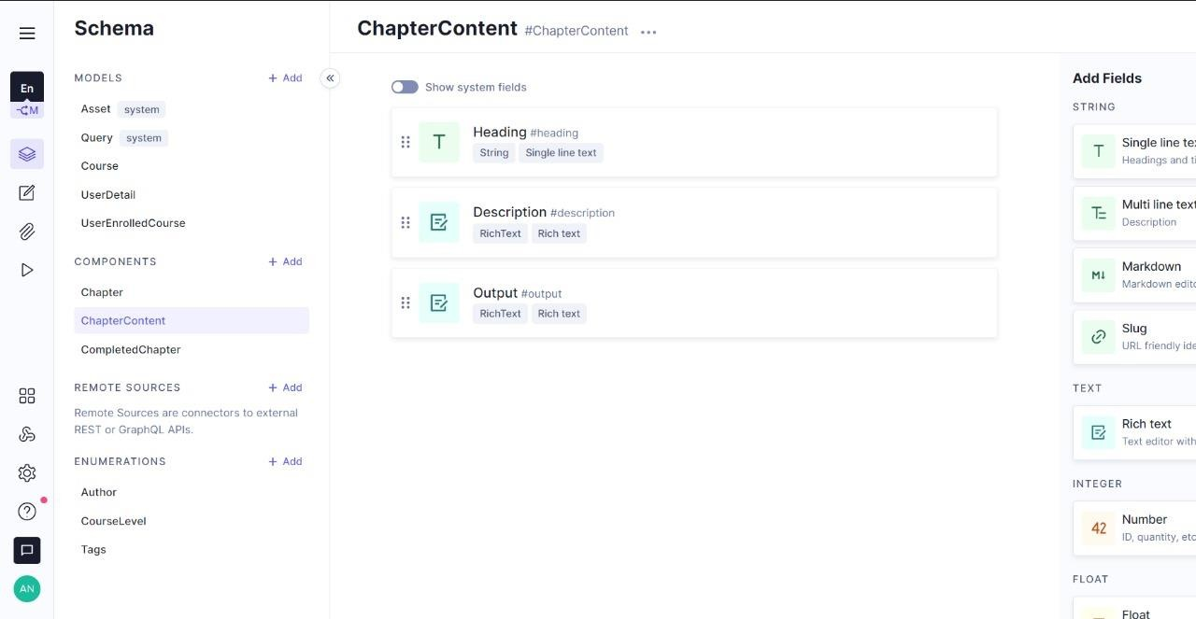

**CompletedChapter:**

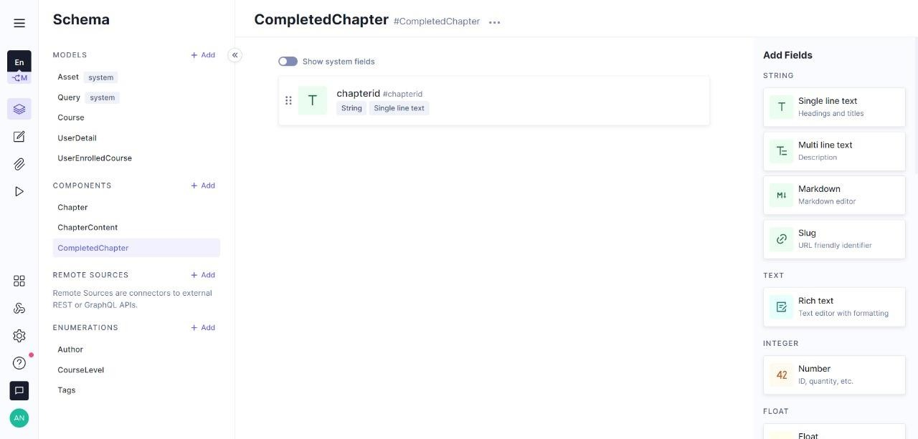

**Enumerations:**

**Author:**

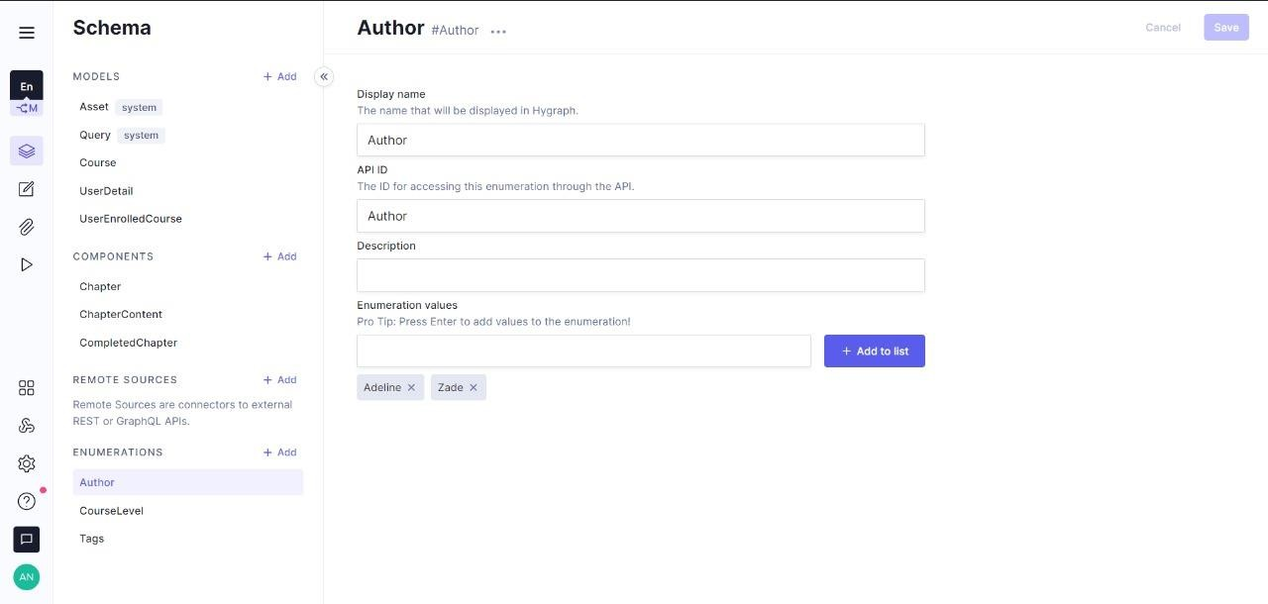

**CourseLevel:**

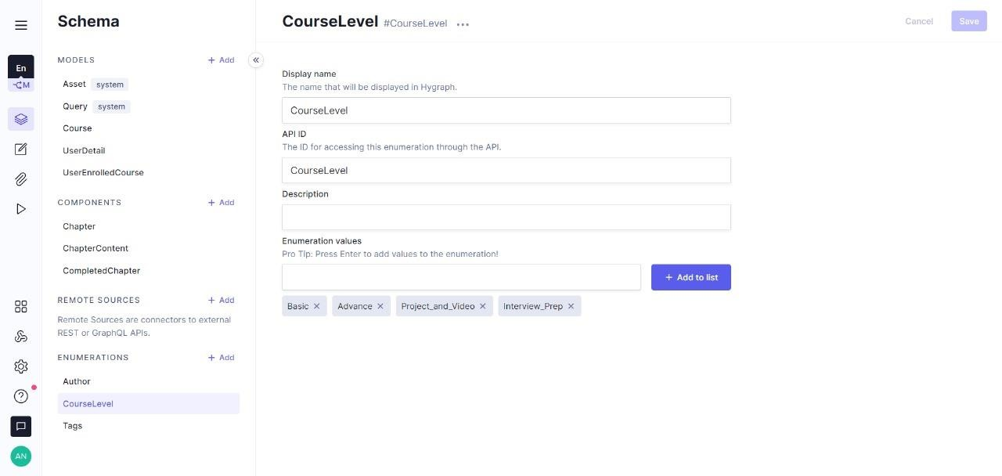

**Tags:**

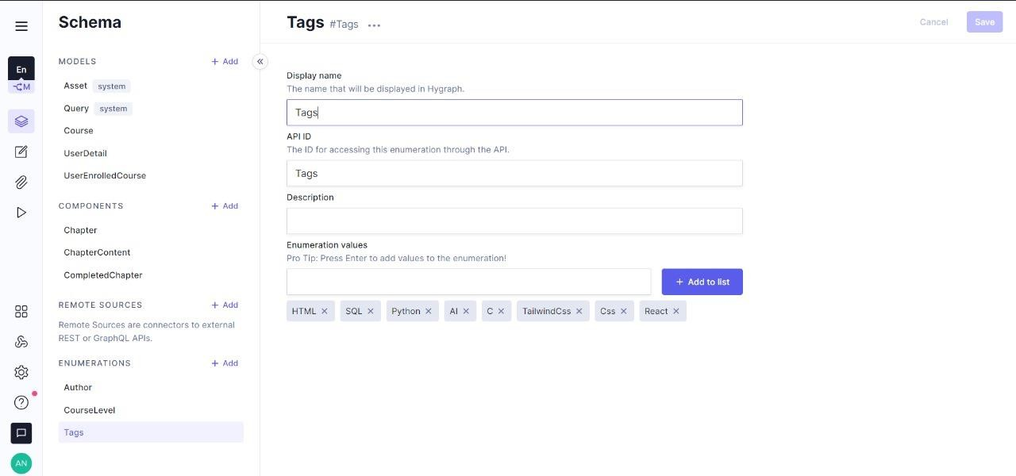

* 1. **CONTENT:**

**Course:**

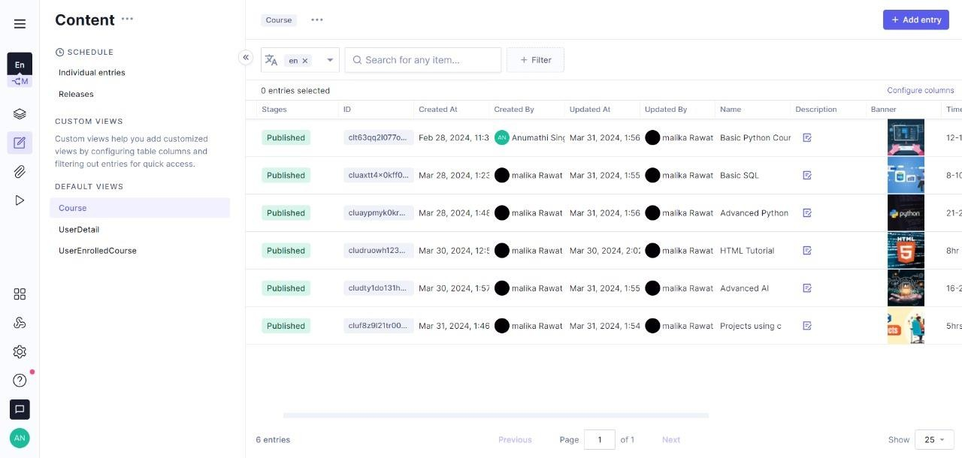

**UserDetail:**

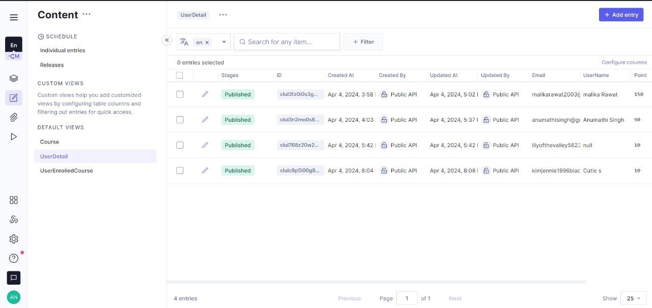

**UserEnrolledCourse:**

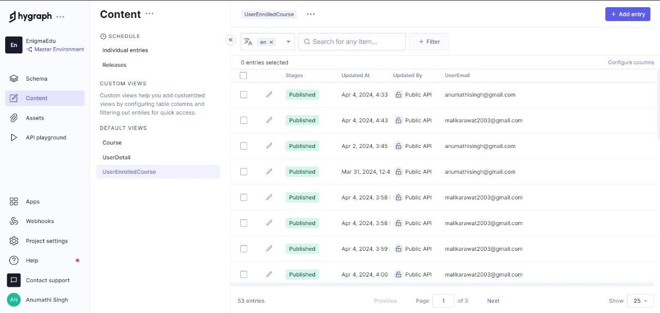

* 1. **ASSETS:**

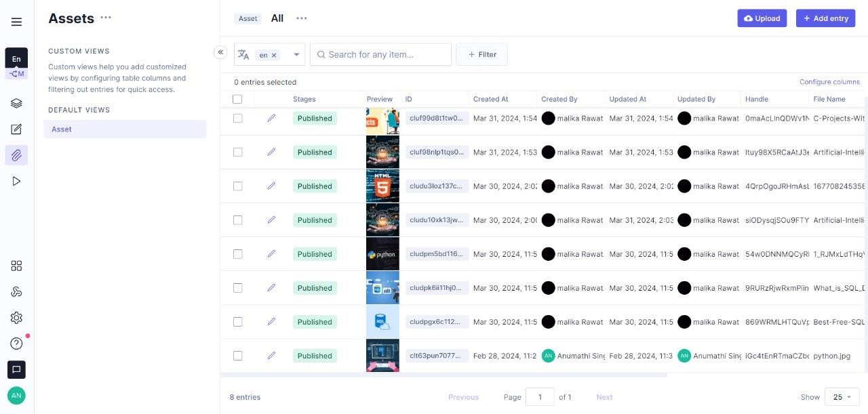

* 1. **API PLAYGROUND:**

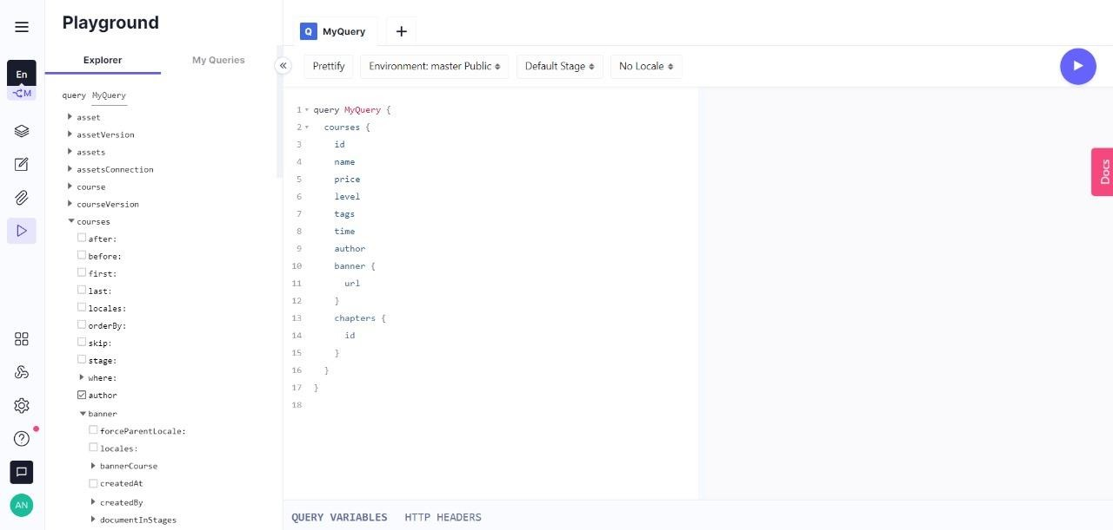

**CLERK(Authentication):**

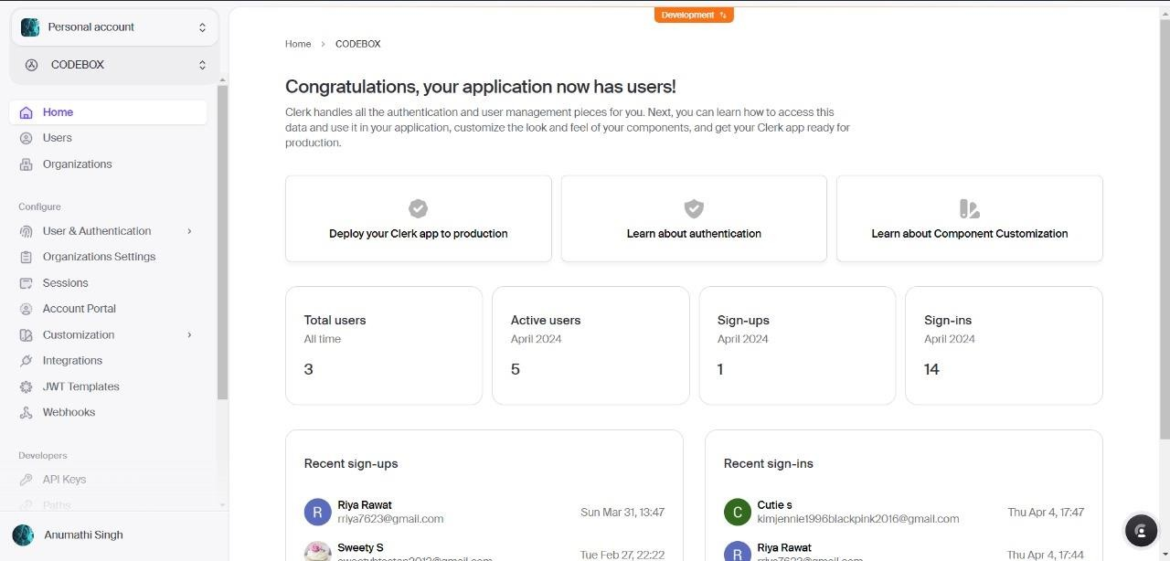

# USER SCREEN:

1. **SignIn Screen:**

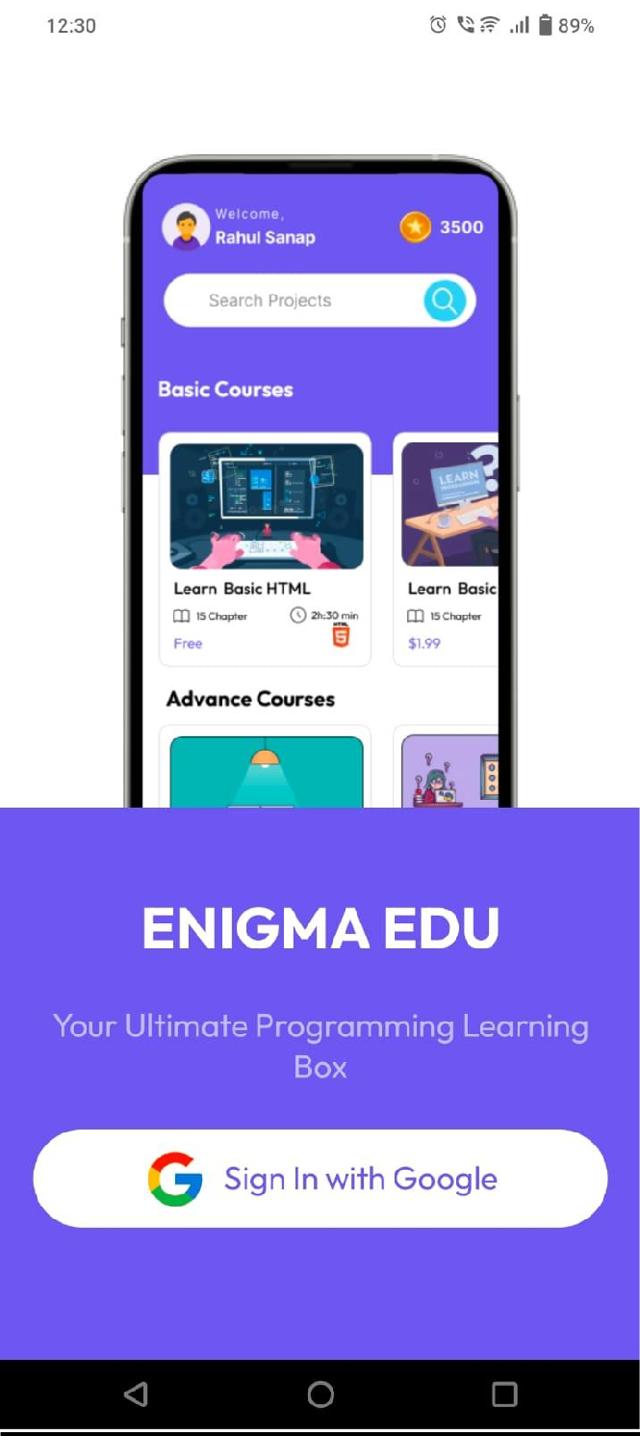

1. **HomePage:**

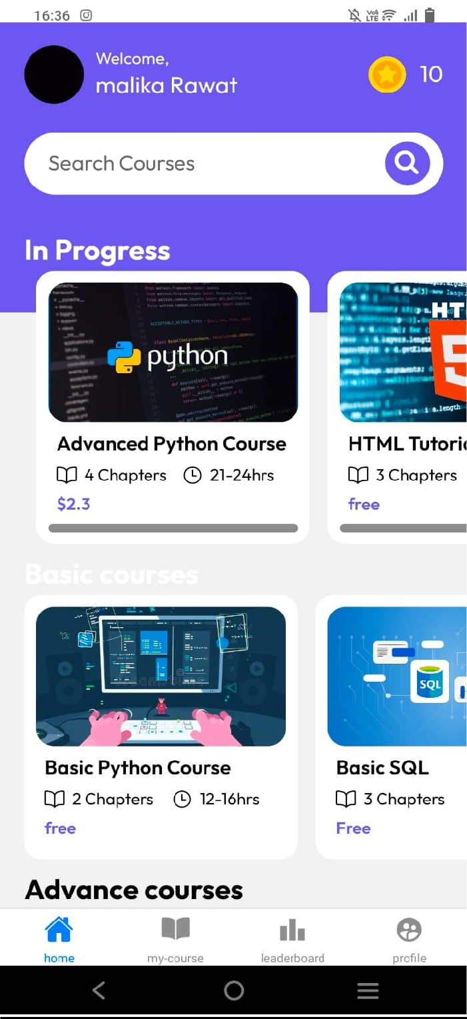

1. **MyCourses Screen:**

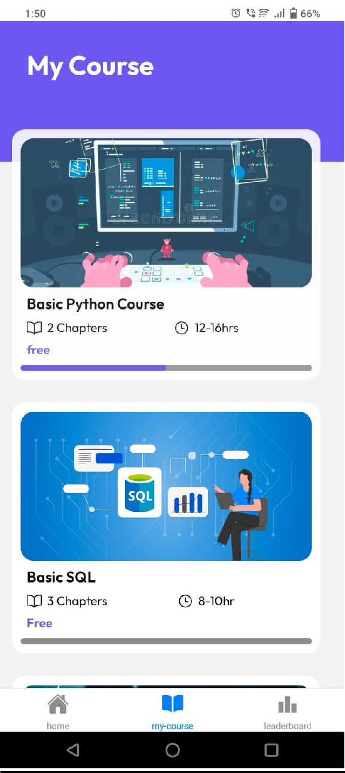

1. **CourseEnrollement:**

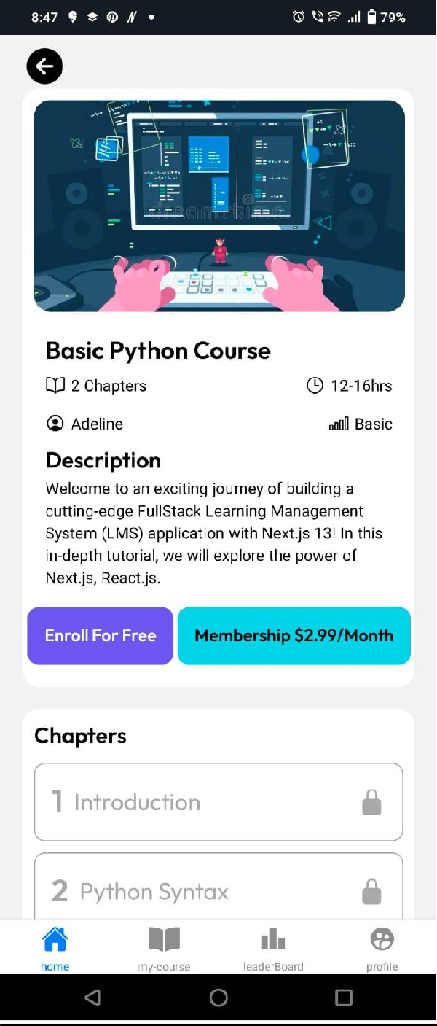

1. **CourseContent:**

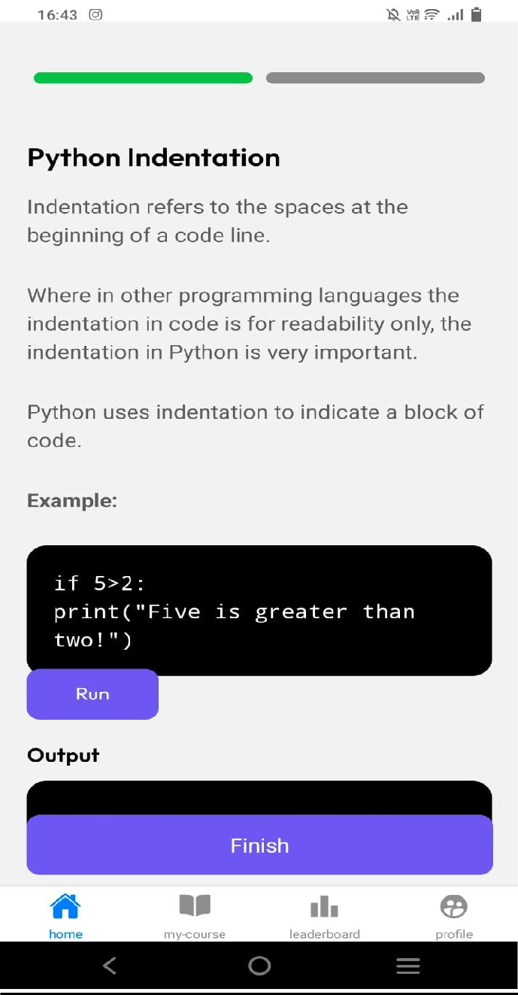

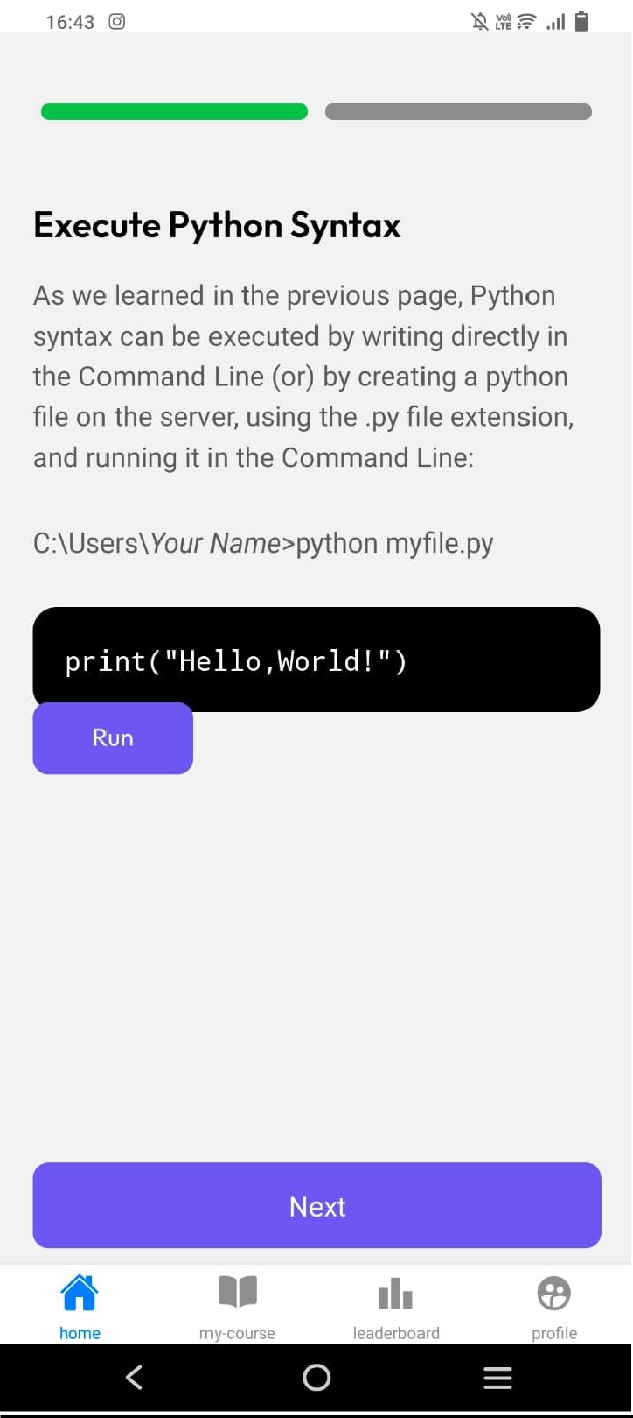

1. **LeaderBoard:**

**Singleuser:**

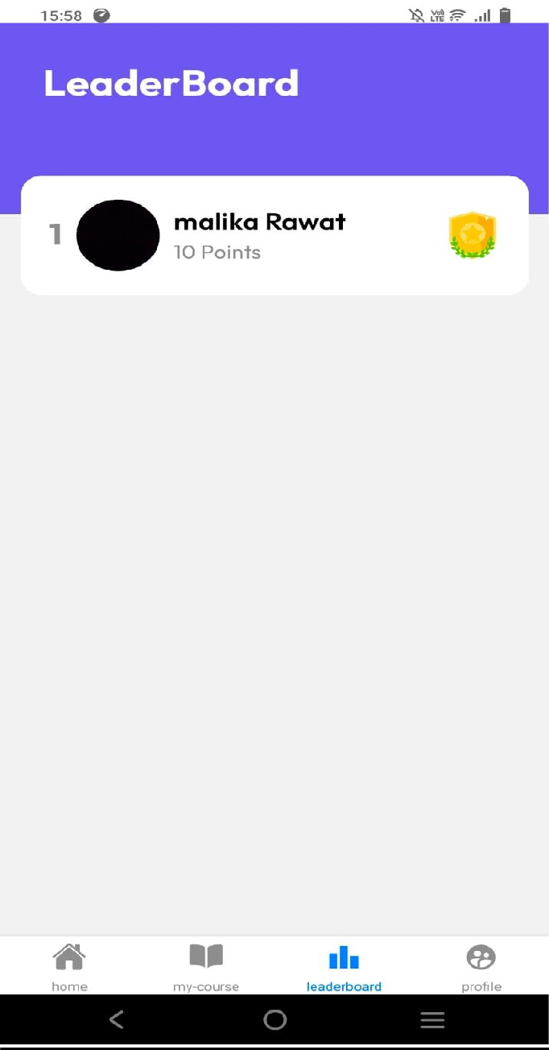

**MultipleUser:**

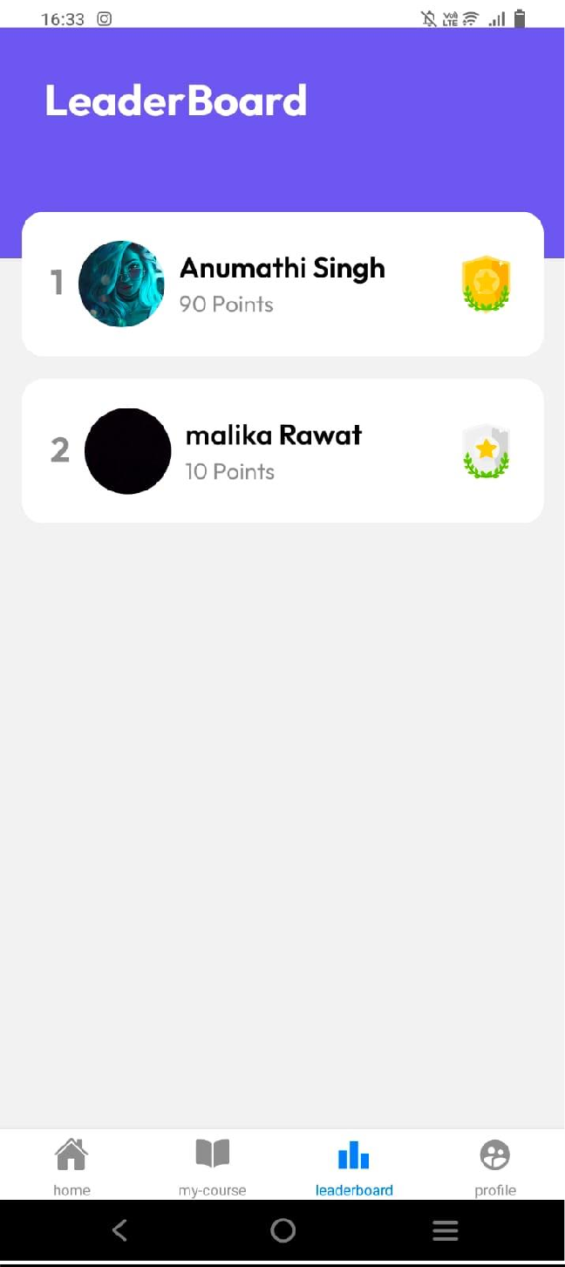

**ChangeInLeaderboard due to point:**

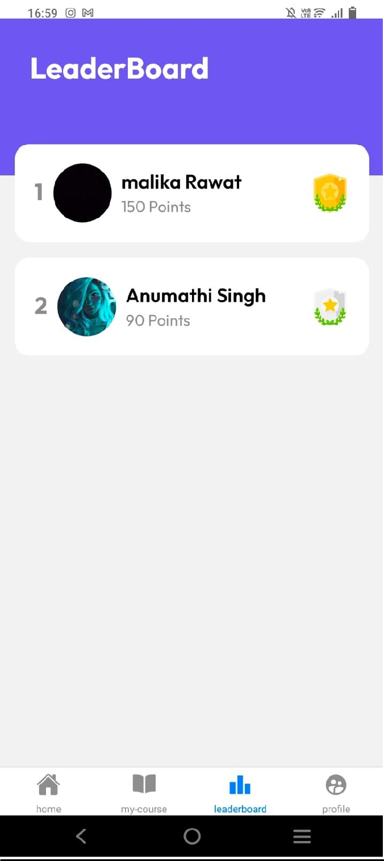

# SAMPLE CODE:

**LOGIN SCREEN:**

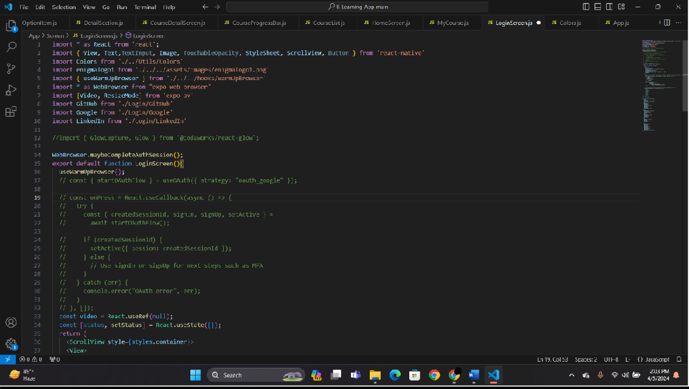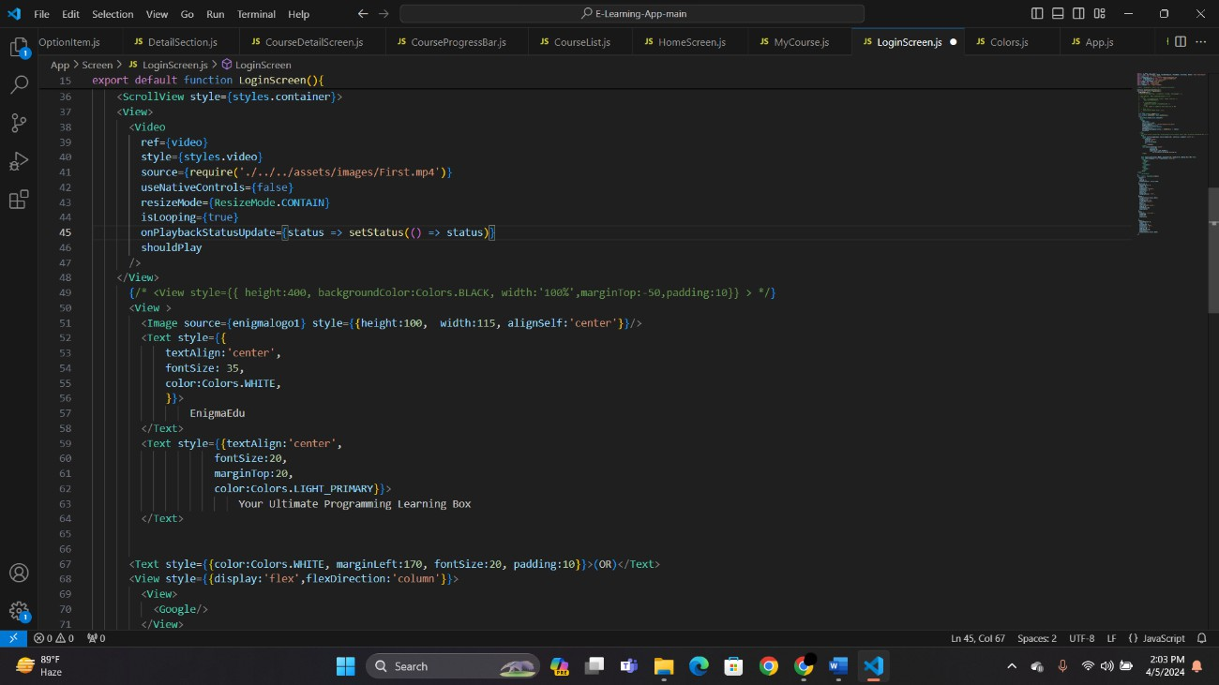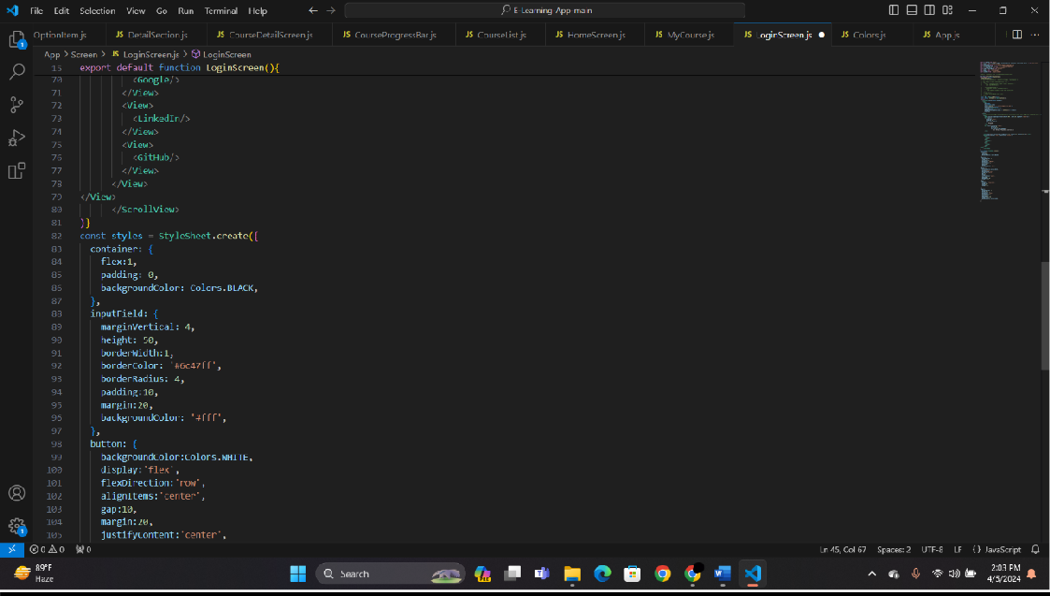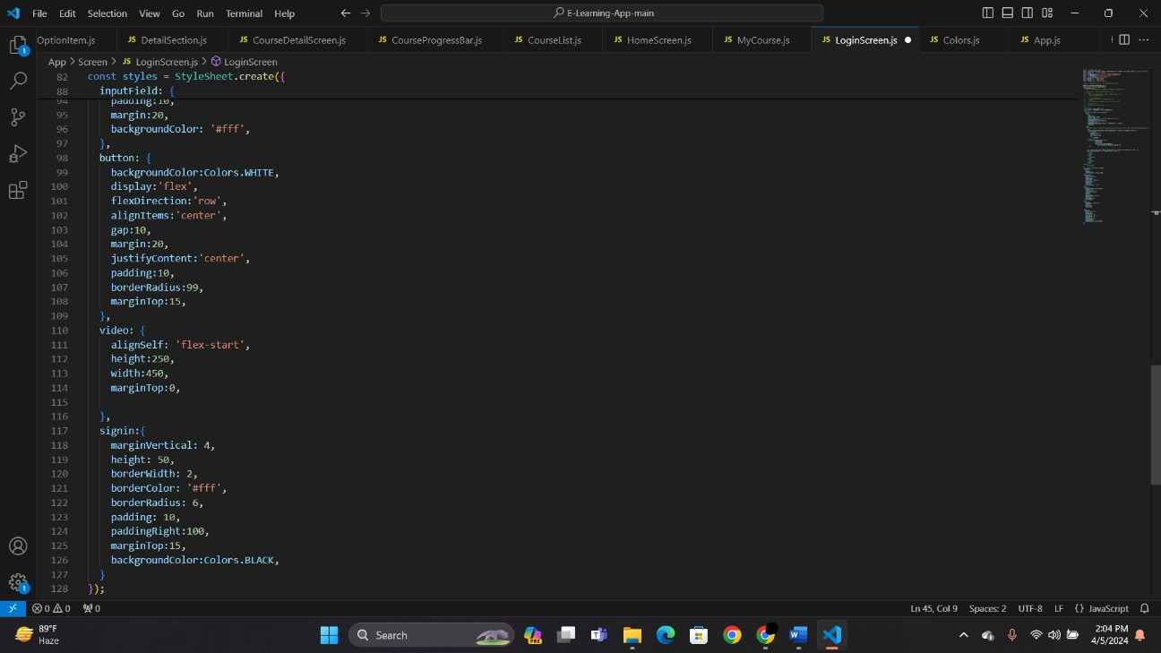

**HOMESCREEN:**

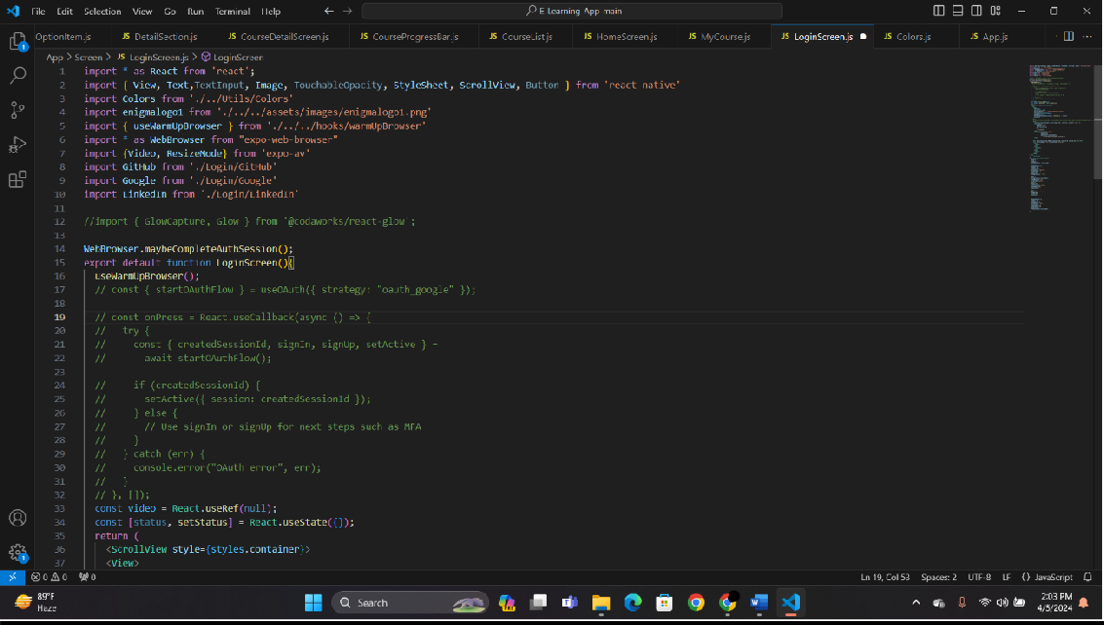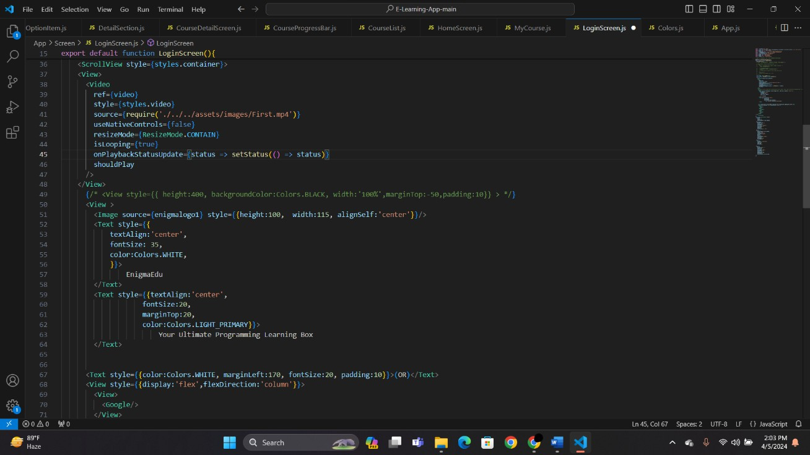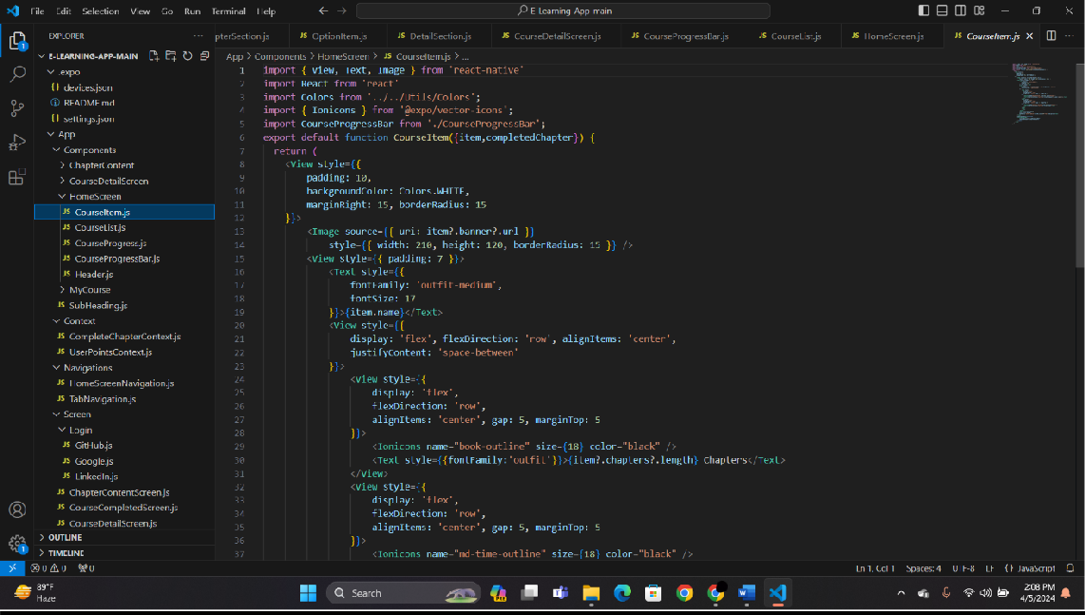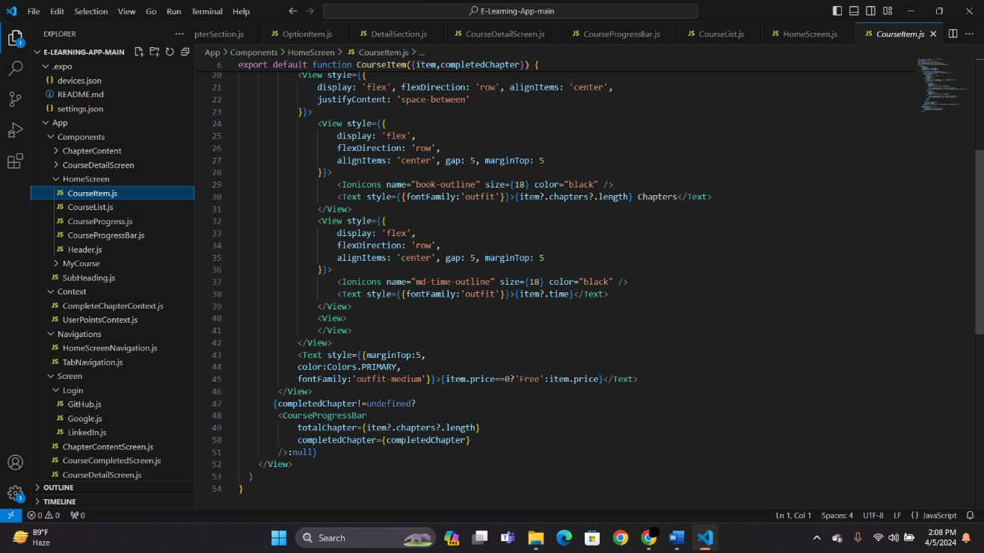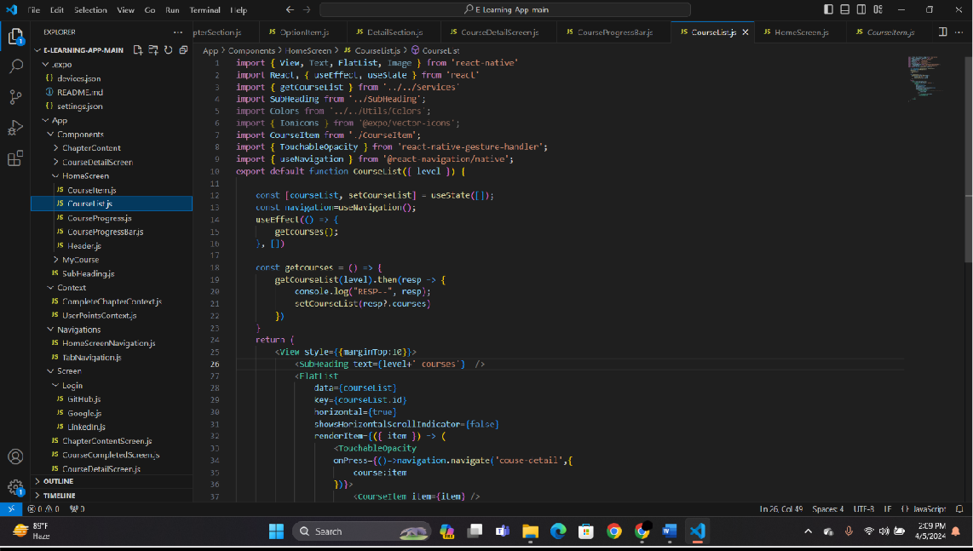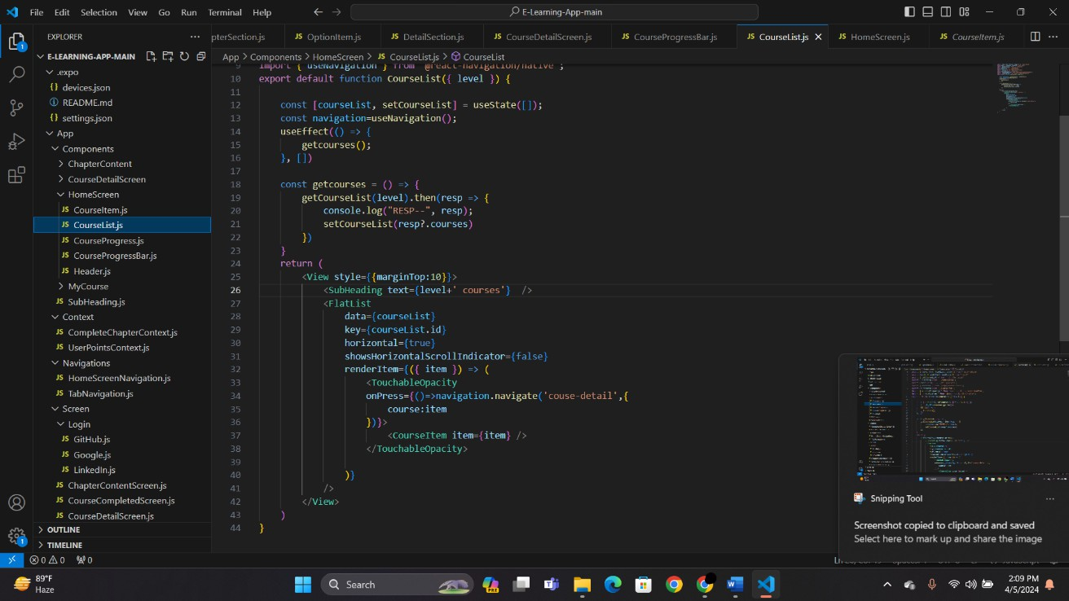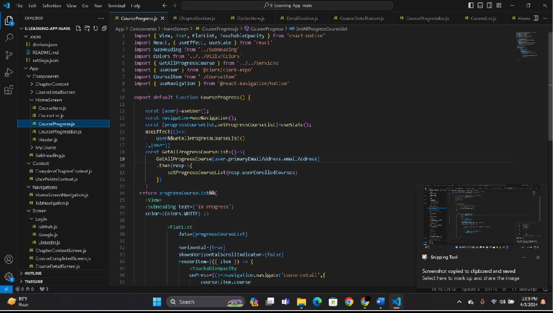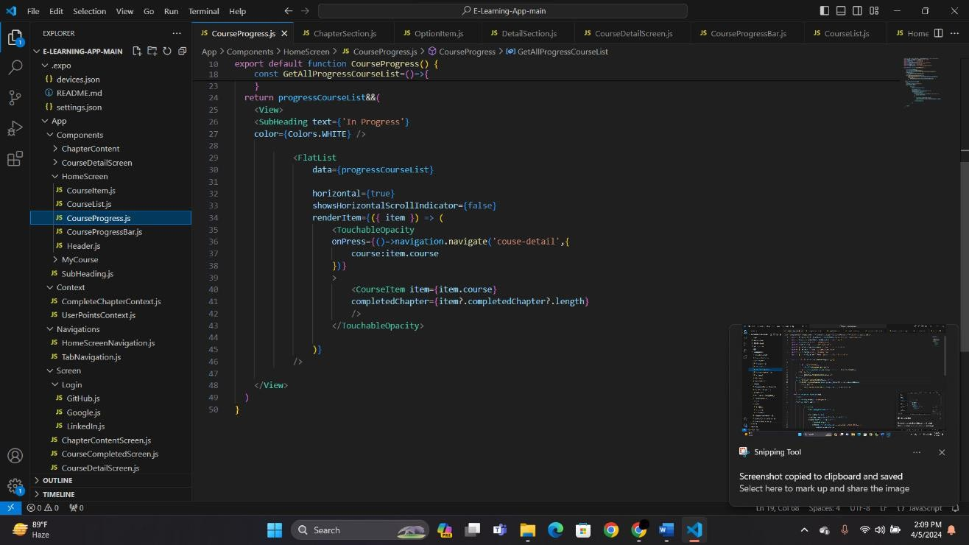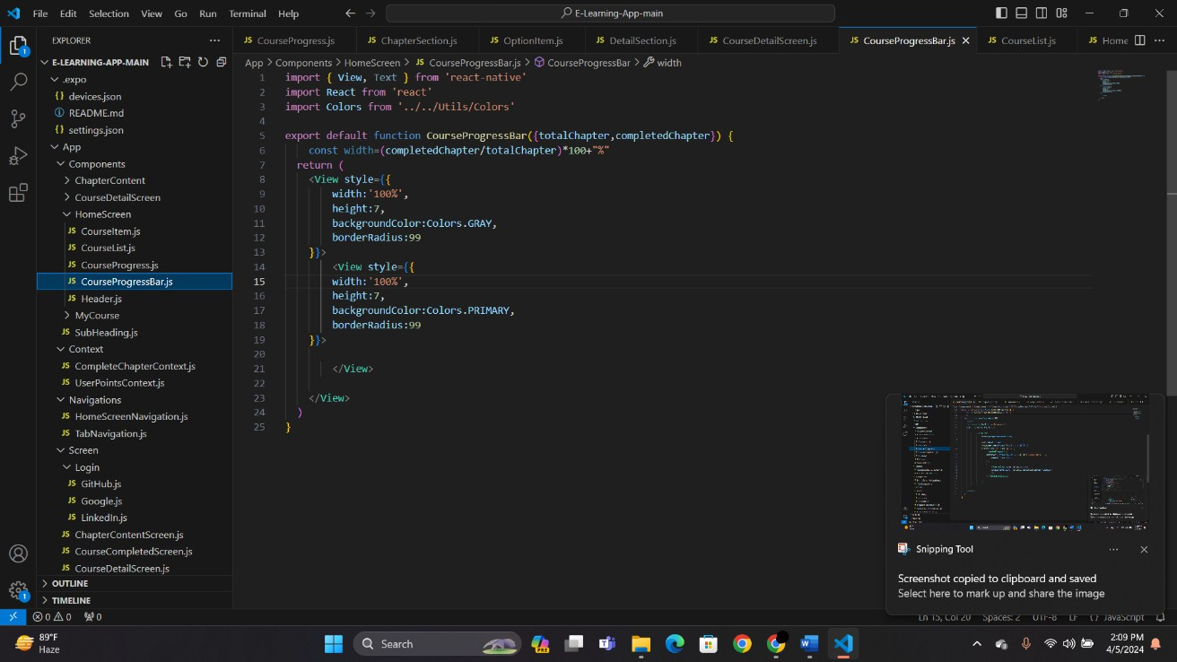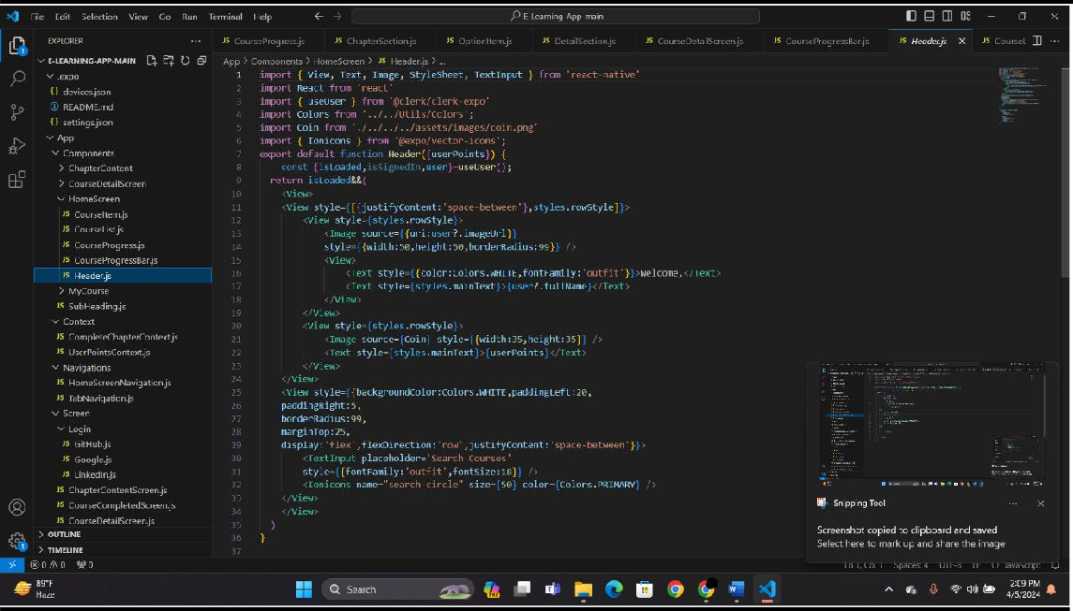

**COURSE-DETAILS:**

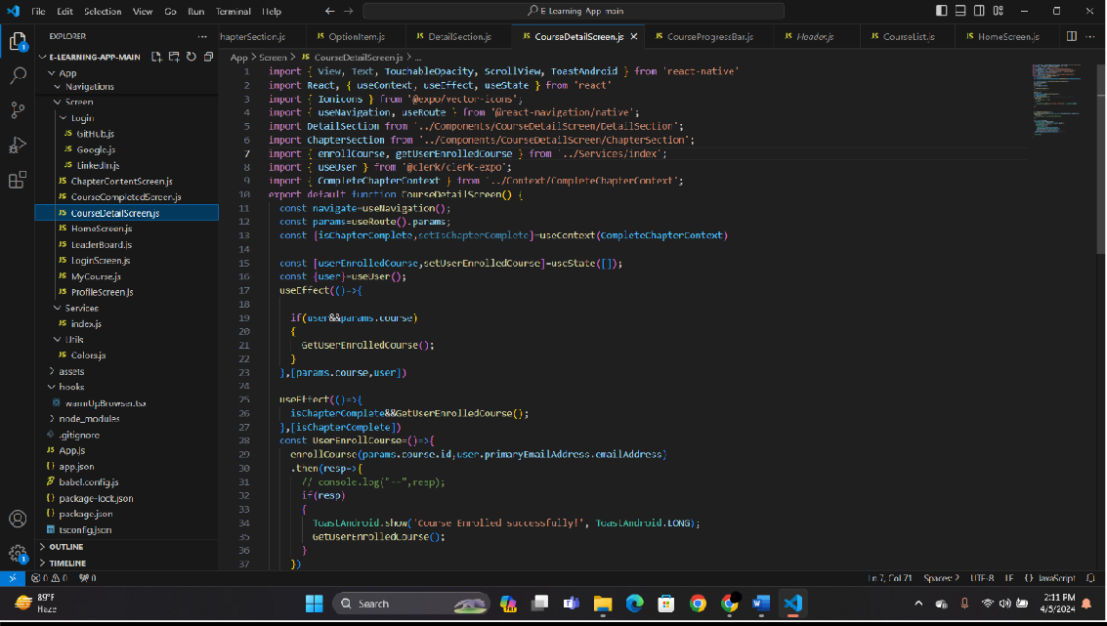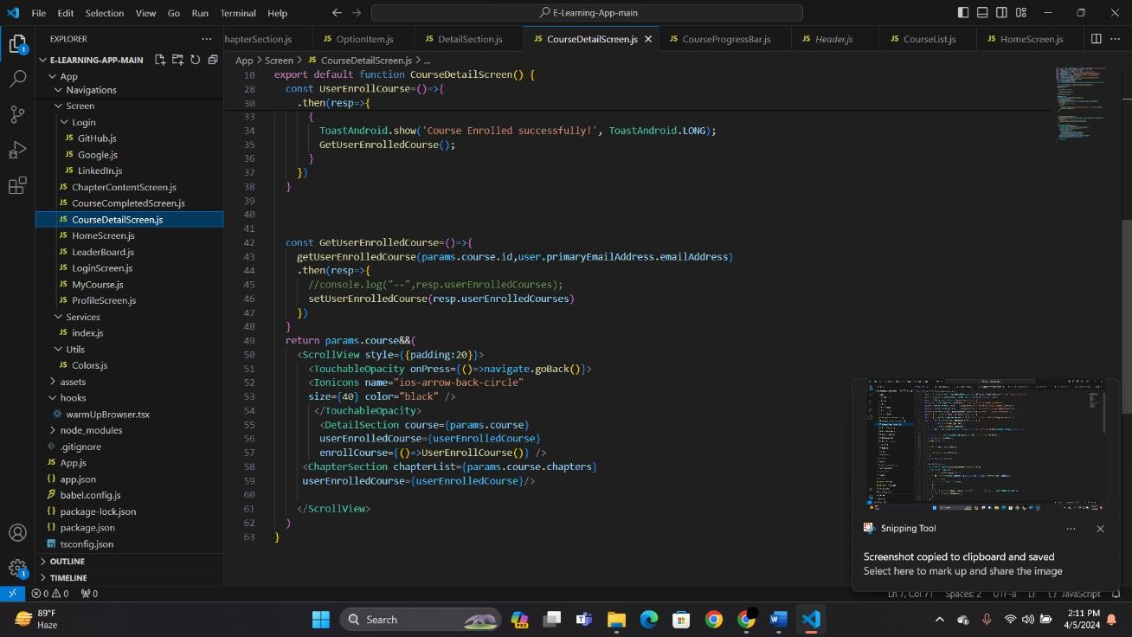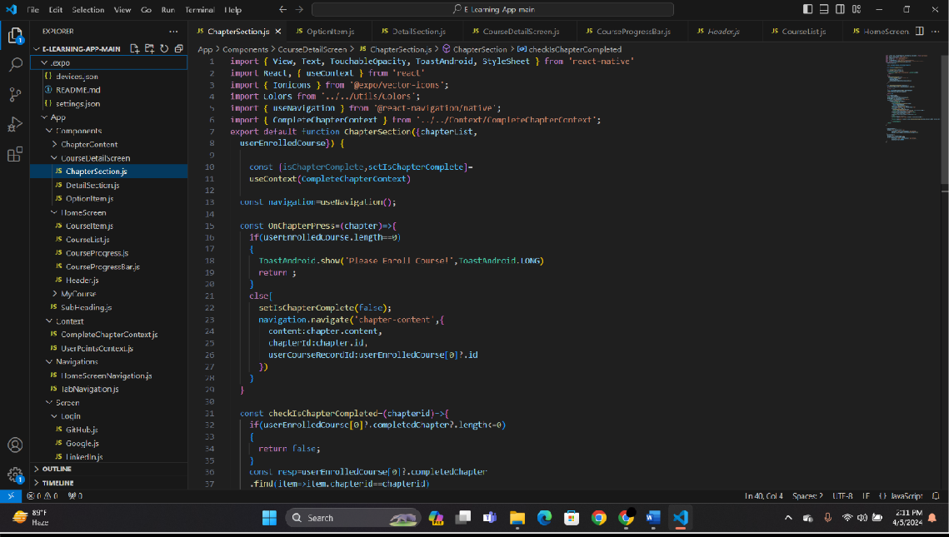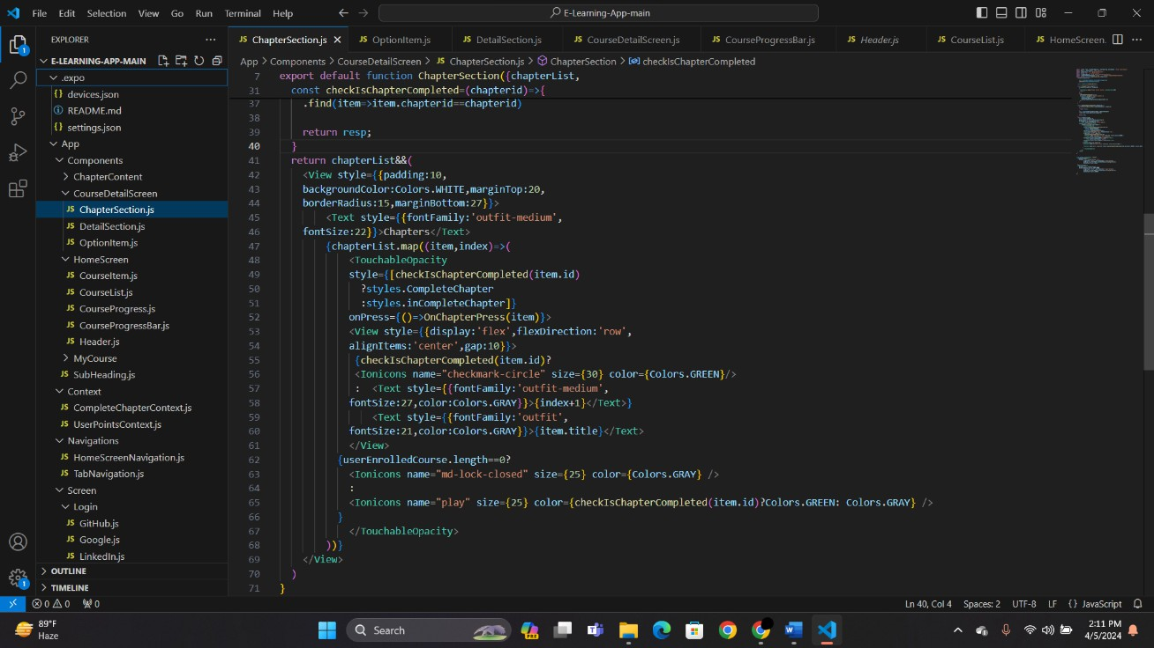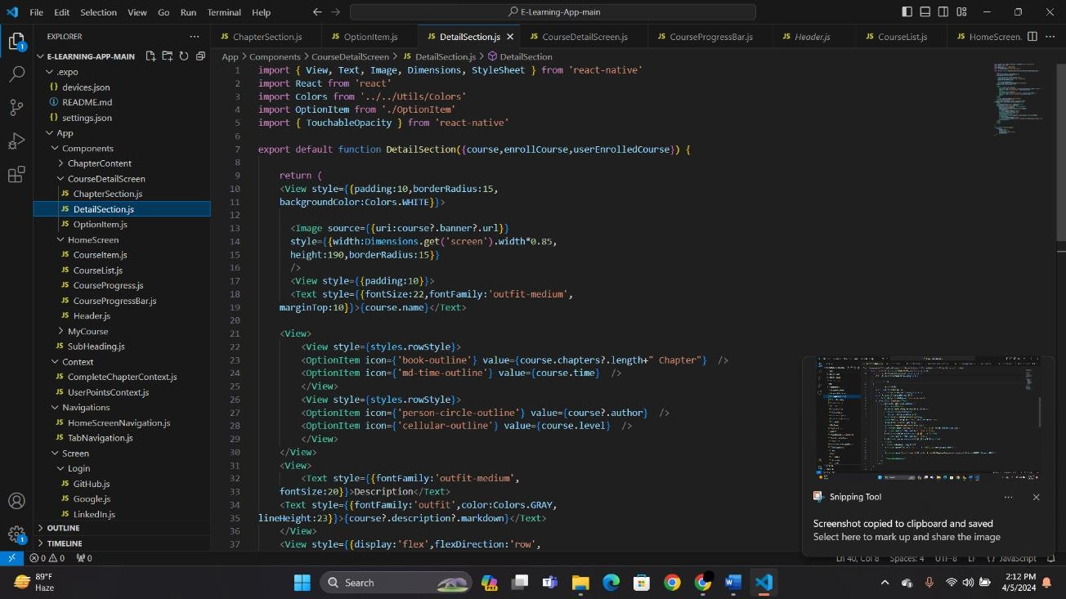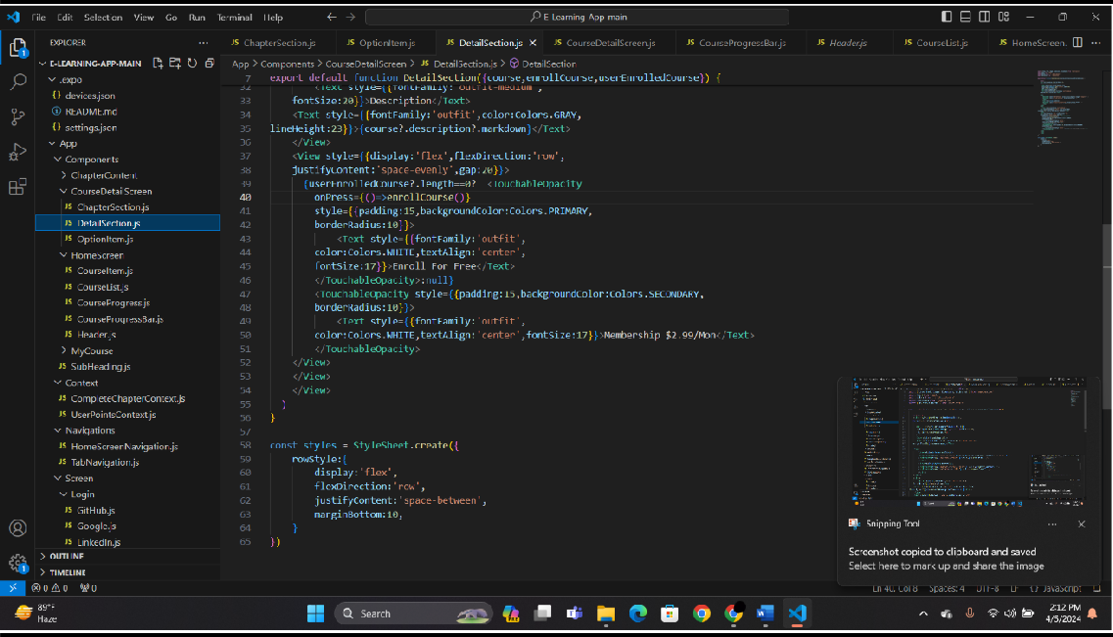

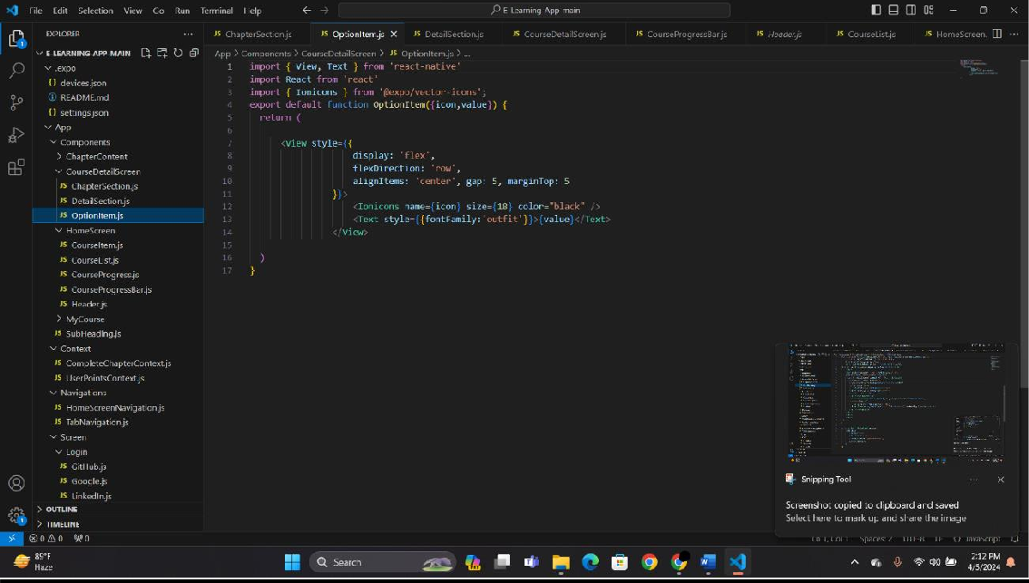

**CHAPTER-CONTENT:**

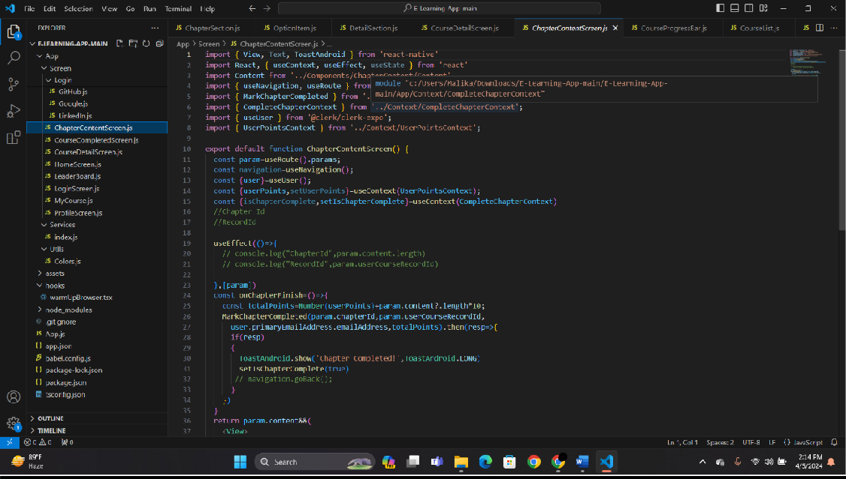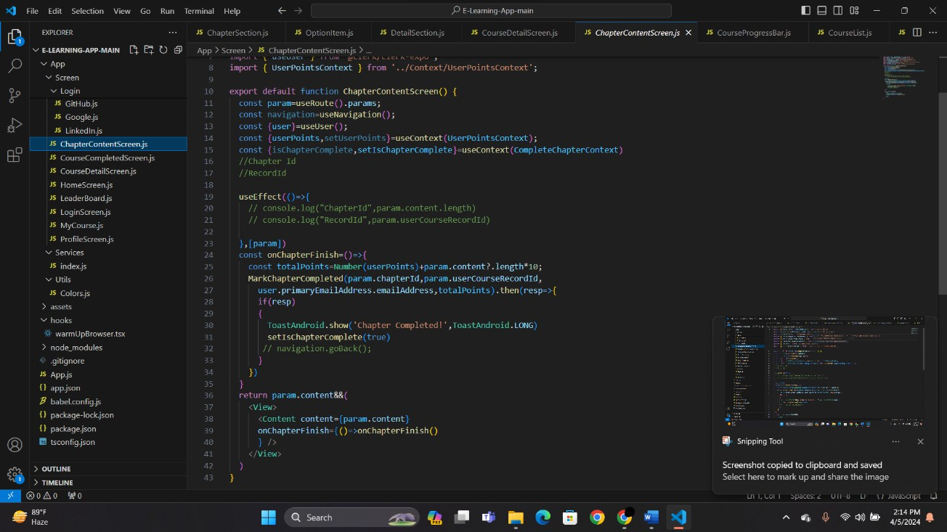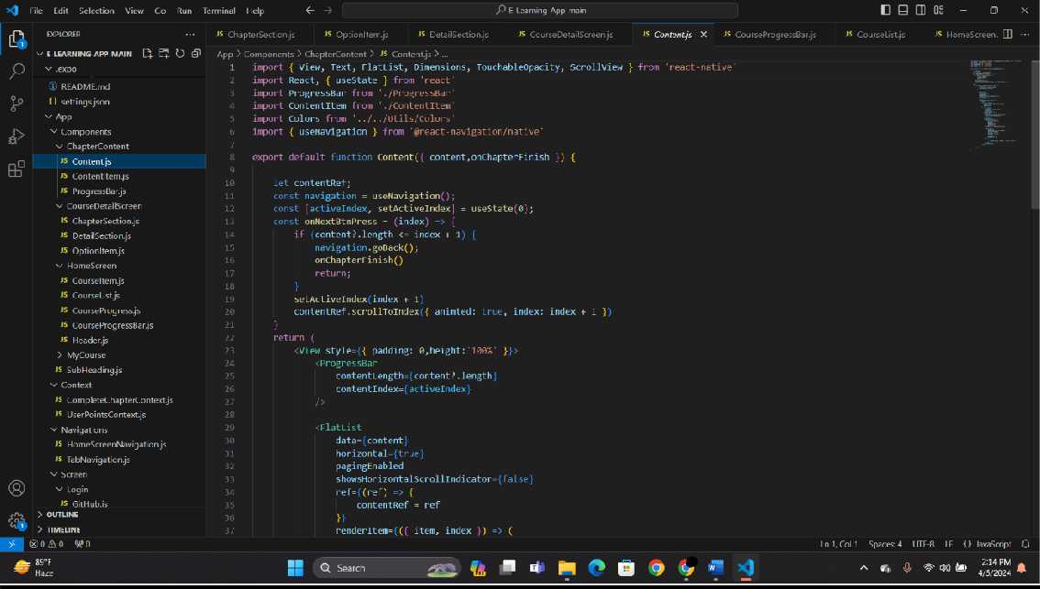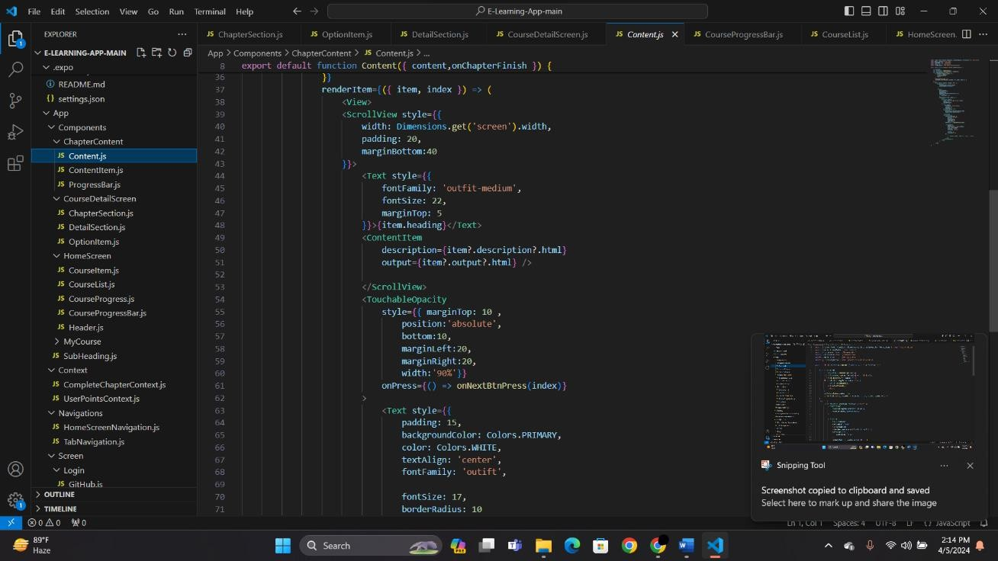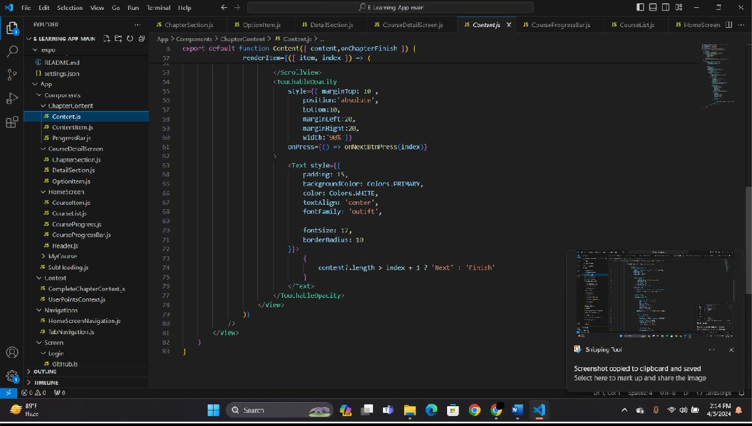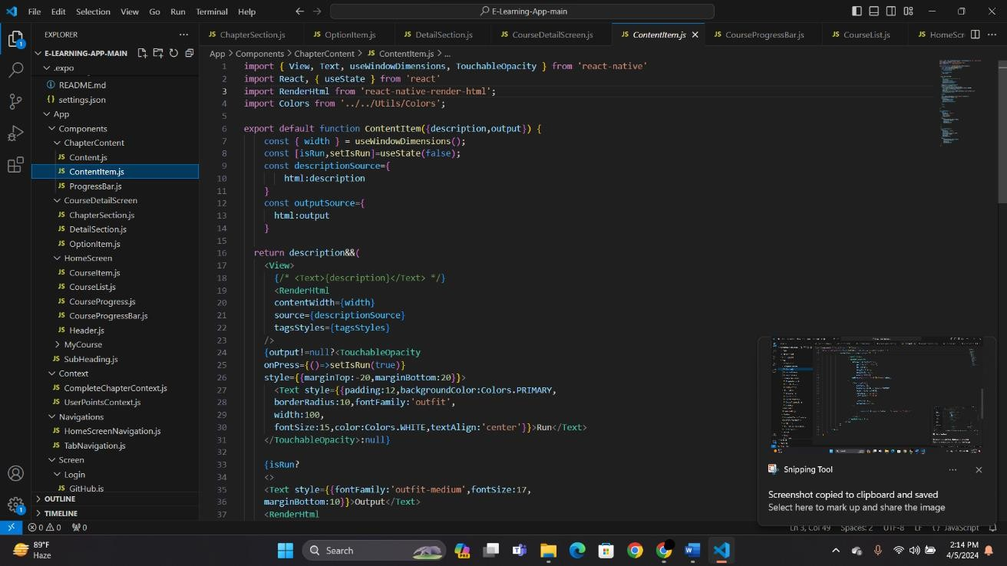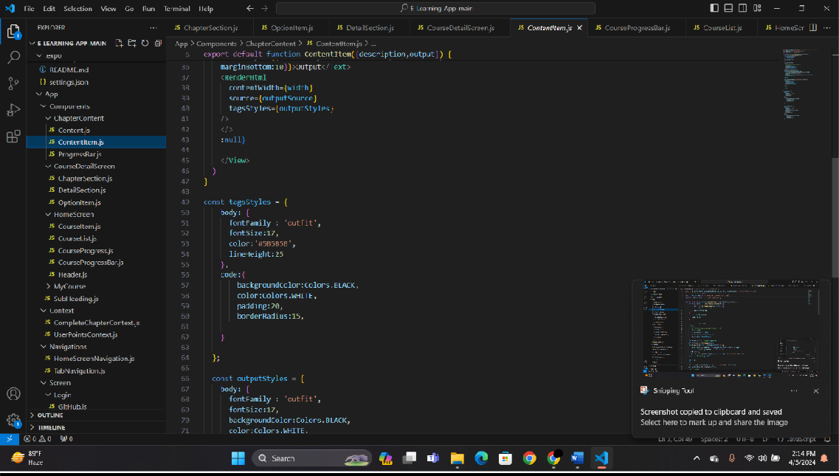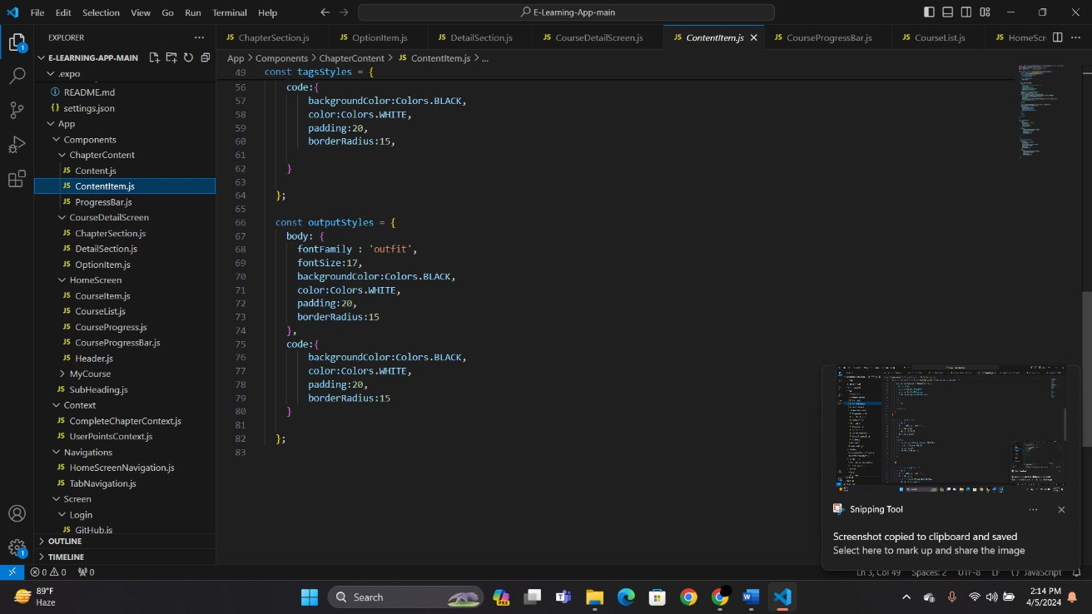

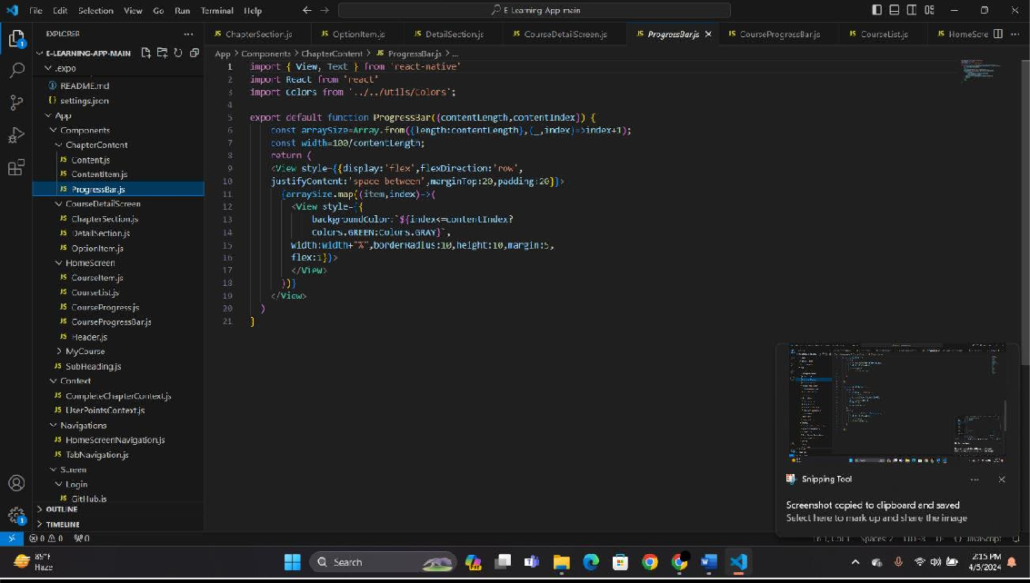

**LEADERBOARD:**

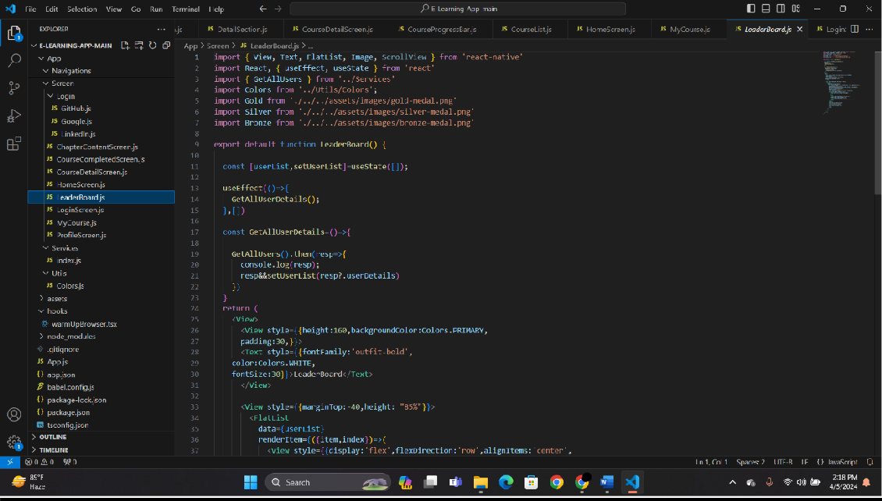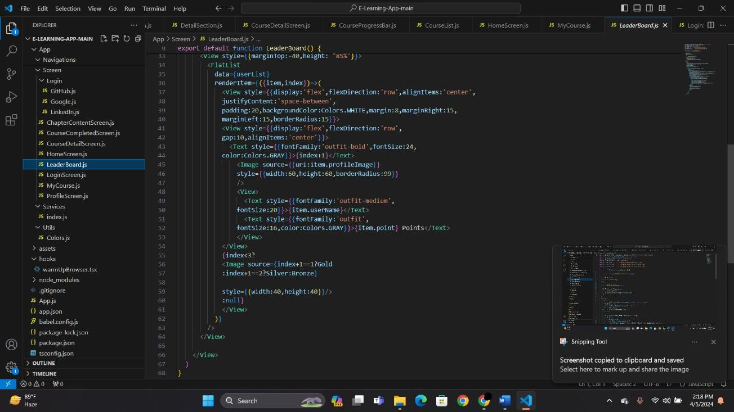

**MY-COURSE:**

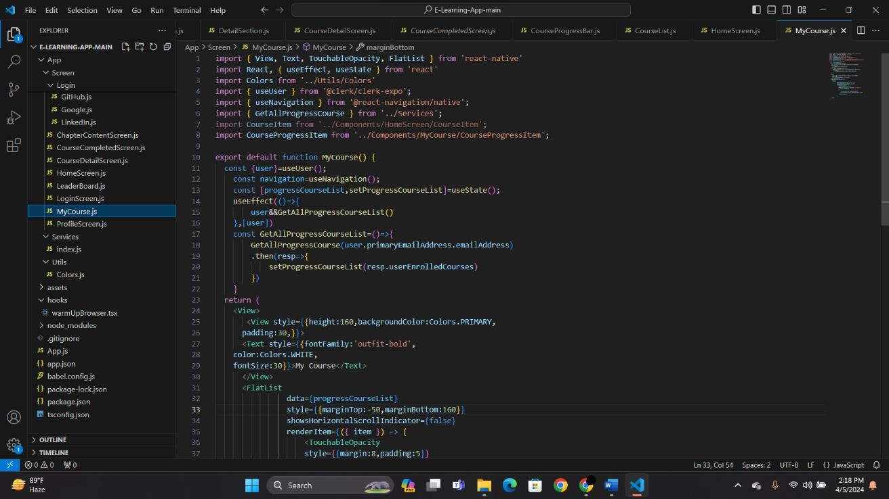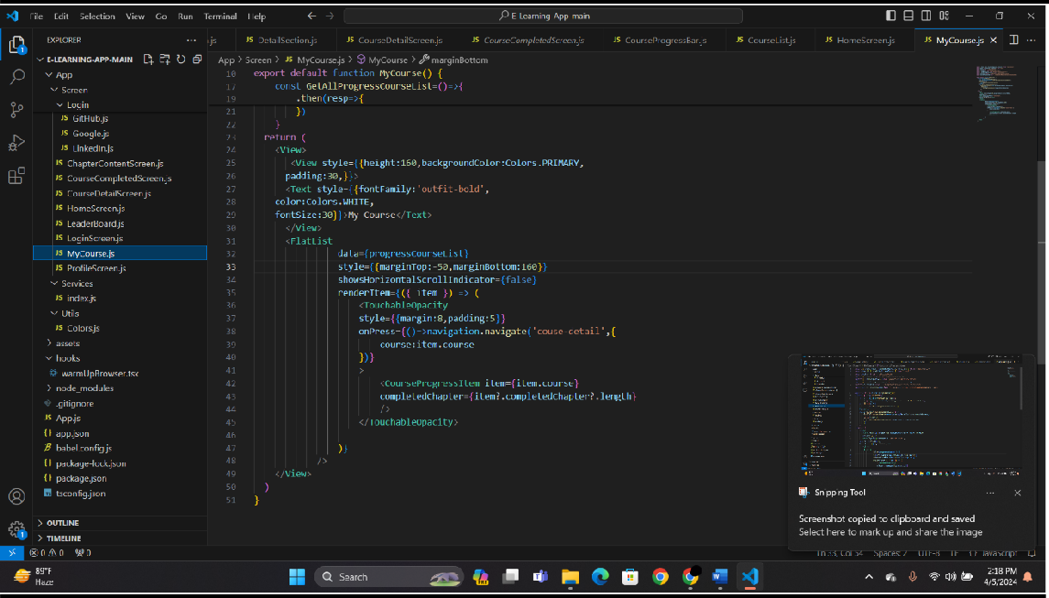

# TESTING

Testing is the process of executing a program with the explicit goal of identifying and eliminating errors. The primary objective is to ensure that the system functions as expected, adheres to requirements, and delivers a reliable user experience.

**TESTING METHODOLOGIES:**

* Black Box Testing
* Software Testing
* White Box Testing

**SOFTWARE TESTING**

Software testing evaluates the functionality and correctness of the application by executing test cases. A well-designed test case should have a high probability of detecting potential defects.

**Key Purposes of Software Testing:**

* Defect Detection: Identify errors, bugs, and inconsistencies in the system before deployment.
* Reliability Estimation: Assess system performance under various conditions to ensure stability.

**BLACK BOX TESTING**

Black box testing is applied at the system or module level, focusing on verifying the software’s input and output functionality without analyzing its internal code.

Implementation in the Project:

* Checking if gym members can successfully log in and view their workout schedules.
* Verifying whether payment transactions are processed correctly.
* Ensuring that trainers can assign workout plans and members can access them.
* Testing if product purchases and order tracking work correctly.

**WHITE/GLASS BOX TESTING**

White box testing involves analyzing the internal workings of the software, including code logic, data flows, and control structures.

Implementation in the Project:

* Ensuring that the authentication system correctly verifies user roles (Admin, Trainer, Member).
* Checking whether database queries fetch correct data for attendance tracking.
* Testing backend functions for processing membership renewals and workout assignments.
* Validating API endpoints for communication between frontend and backend.

**SOFTWARE TESTING STRATEGIES**

The testing approach for SangLehar Gym Fitness Management Systemfollows a structured methodology:

1. Unit Testing
2. Integration Testing
3. Validation Testing
4. System Testing

**UNIT TESTING**

Unit testing focuses on verifying the functionality of individual components/modules in isolation. It is a white-box testing approach that ensures each function or feature works as expected.

Implementation in the Project:

* Testing user authentication (login/logout/registration).
* Validating database operations for adding/removing members.
* Checking whether the attendance system correctly records check-ins and check-outs.
* Ensuring the payment gateway processes transactions securely.

Benefits of Unit Testing:

* Improves code reliability and minimizes errors in production.
* Ensures that changes in one module do not affect others.
* Increases code reusability by enforcing modular development.

**INTEGRATION TESTING**

Integration testing ensures that multiple components work together as expected. It verifies that data flows correctly between modules.

Implementation in the Project:

* Ensuring that a trainer assigning a workout plan reflects correctly in the member’s dashboard.
* Validating that membership renewal updates the payment history.
* Checking whether gym product purchases update order records and inventory.

Analogy:  
Just like assembling a ballpoint pen where individual parts (cap, ink cartridge, body) are tested separately before assembly, different modules of the gym management system are unit-tested first and then integrated for functional validation.

**VALIDATION TESTING**

Validation testing ensures that the system meets user requirements and business needs.

Implementation in the Project:

* Confirming that members can successfully track their progress and receive personalized workout plans.
* Verifying that trainers can manage their assigned members efficiently.
* Ensuring that gym administrators can monitor payments, attendance, and reports effectively.

Objective: To guarantee that the system functions according to the intended requirements, providing a seamless user experience.

**SYSTEM TESTING**

System testing evaluates the software as a whole, ensuring that all integrated components work together as expected.

Implementation in the Project:

* Simulating real-world scenarios where multiple users access the system simultaneously.
* Checking overall performance under high user loads.
* Ensuring that different user roles (Admin, Trainer, Member, Guest) function as intended.

Analogy:  
After a ballpoint pen is fully assembled, it undergoes a final test to check if it writes smoothly. Similarly, system testing ensures that all modules in the gym management system work harmoniously.

# IMPLEMENTATION

Implementation is the process of deploying and executing the developed system in a real-world environment. It involves setting up the software, configuring it for use, and ensuring smooth operation for all intended users. The successful implementation of **SangLehar Gym Fitness Management System**will follow a structured approach to ensure minimal disruptions and maximum efficiency.

**Steps for Implementation**

1. **Platform Compatibility:**
   * The application is a **web-based** system accessible via any modern browser.
   * It is designed to work on **desktop and mobile browsers** without requiring a dedicated mobile app.
2. **Deployment on Web Servers:**
   * The **Django-based** backend will be deployed on a **cloud-based web server** (such as AWS, DigitalOcean, or Heroku).
   * The **MySQL/PostgreSQL** database will be hosted on a secure cloud platform.
   * A **domain name and SSL certificate** will be set up to ensure secure access to the website.
3. **GitHub Download & Deployment:**
   * The **source code** will be hosted on **GitHub** for developers and contributors.
   * Users can **clone or download** the repository using:

**git clone https://github.com/sangitarawlo/SangLehar-FitnessFlow-Full-Stack-Web-Application**

* + Developers can set up the system locally by installing dependencies and running the Django server:

**pip install -r requirements.txt**

**python manage.py migrate**

**python manage.py runserver**

* + **Comprehensive documentation** will be provided to assist developers with installation and configuration.

1. **User Registration & Authentication:**
   * **Admins, Trainers, and Members** will register on the platform using their personal details.
   * Secure authentication will be enforced using **username-password authentication**.
   * Users will receive a **verification email** to activate their accounts.
2. **Admin Setup & System Configuration:**
   * The **Admin** will configure gym details, membership plans, trainer assignments, and workout schedules.
   * **Payment gateway integration** will be set up for secure transactions.
   * The **product management module** will be configured for selling gym-related items online.
3. **Trainer & Member Onboarding:**
   * **Trainers** will be assigned to members based on their fitness goals.
   * Trainers will upload **custom workout plans, diet charts, and training videos**.
   * Members will be able to **track progress, view schedules, and communicate with trainers**.
4. **Testing & Quality Assurance:**
   * The system will undergo **unit testing, integration testing, and system testing** to identify and fix potential issues.
   * A **pilot rollout** will be conducted with selected gym members and trainers for real-world testing.
   * **User feedback** will be collected to make necessary improvements.
5. **Full System Deployment:**
   * Once all issues are resolved, the **final version** of the system will be deployed for all users.
   * Regular **maintenance, updates, and feature enhancements** will be carried out based on user feedback.

By following this structured implementation plan, **SangLehar Gym Fitness Management System**will provide an **efficient, scalable, and user-friendly** gym management solution.

# MAINTENANCE

Software maintenance is a critical phase in the software development lifecycle, ensuring that **SangLehar Gym Fitness Management System**continues to function efficiently, securely, and in alignment with user needs. Since user requirements evolve over time, ongoing updates and improvements are essential for long-term usability and performance.

**Types of Maintenance**

1. **Corrective Maintenance**
   * Fixing any **bugs, errors, or vulnerabilities** that arise during the system’s usage.
   * Addressing **unexpected failures** caused by unpredicted input values or system conflicts.
   * Performing **regular debugging and log analysis** to maintain stability.
2. **Adaptive Maintenance**
   * Modifying the system to accommodate changes in **hardware, software, or external integrations** (e.g., API updates, payment gateways).
   * Upgrading the system to support **new browser versions and devices**.
   * Adapting the platform to comply with **new security policies or legal regulations**.
3. **Perfective Maintenance**
   * Enhancing system **performance, usability, and functionality** based on user feedback.
   * Implementing **new features** to improve trainer-member interactions, analytics, or reporting.
   * Optimizing **database queries, load times, and server efficiency** to handle growing users.
4. **Preventive Maintenance**
   * Conducting **regular system audits** to identify potential failure points.
   * Applying **security patches, backups, and performance monitoring** to avoid major breakdowns.
   * Future-proofing the application by keeping it **modular and scalable**.

**Future Enhancements**

* **Integration of AI-Based Personalization**
  + Recommending personalized **workout plans and diet charts** based on AI-driven analytics.
  + Implementing **chatbots for automated customer support** and query resolution.
* **Improved Security Features**
  + Upgrading authentication methods with **biometric login and advanced encryption**.
  + Implementing **role-based access control (RBAC)** for better data protection.
* **Mobile Application Development**
  + Expanding to a **dedicated mobile app** for iOS and Android users.
  + Introducing **push notifications for workout reminders, membership renewals, and promotions**.
* **IoT Integration for Smart Fitness Tracking**
  + Syncing with **wearable devices (Fitbit, Apple Watch, etc.)** for real-time fitness tracking.
  + Implementing **automated check-ins** using NFC or QR codes for gym attendance.
* **Advanced Analytics & Reports**
  + Enhancing **data visualization dashboards** for gym admins.
  + Implementing **AI-driven insights** to optimize trainer schedules, membership retention, and sales trends.

By adopting **continuous monitoring, updates, and enhancements**, **SangLehar Gym Fitness Management System**will remain a **reliable, scalable, and future-ready** gym management platform.

# CONCLUSION:

The SangLehar Gym Fitness Management Systemgym management system represents a significant advancement in the digitalization of fitness center operations. By integrating automation, secure data management, and enhanced user engagement, the platform provides a seamless experience for gym administrators, trainers, and members alike. This project not only eliminates the inefficiencies of traditional paper-based management systems but also introduces a structured, organized, and technology-driven approach to fitness tracking and business operations.

Through modular development, the system ensures that various aspects of gym management—such as attendance tracking, workout scheduling, membership handling, trainer interactions, and payment processing—are efficiently handled in a centralized and user-friendly manner. The implementation of role-based access control allows for a secure and customized experience for each user type, ensuring data integrity and privacy.

One of the key highlights of the system is its real-time analytics and reporting capabilities. Gym administrators can now make data-driven decisions regarding memberships, trainer performance, and financial records. Additionally, the system's scalability ensures that it can accommodate future growth, allowing for an increasing number of users without affecting performance.

The security-first approach implemented in SangLehar Gym Fitness Management Systemensures that user authentication, payment transactions, and sensitive personal data are well protected. Encryption, authentication protocols, and role-based access permissions safeguard all interactions within the system. This prevents unauthorized access and ensures compliance with data protection regulations.

From a user experience standpoint, the platform enhances trainer-member interactions by offering customized workout plans, diet recommendations, and progress tracking. This personalization fosters member engagement and motivation, contributing to higher retention rates and a better overall gym experience. The communication module further bridges the gap between trainers and members, allowing for direct and efficient interactions through messaging and feedback systems.

**Future Scope and Improvements**

The foundation laid by SangLehar Gym Fitness Management Systempaves the way for further enhancements and innovation in gym management technology. Some potential future developments include:

* Mobile Application Development to provide a more accessible and convenient experience for members and trainers.
* AI-Powered Workout and Diet Recommendations based on individual progress and goals.
* Wearable Device Integration to sync real-time fitness tracking data from devices like Fitbit, Apple Watch, or smart gym equipment.
* Gamification and Reward Systems to enhance user engagement and motivation.
* Voice-Controlled and Virtual Assistant Features to allow hands-free operation for gym trainers and administrators.
* Multilingual Support to cater to a diverse user base across different regions.

By staying updated with emerging technologies and user expectations, the system can evolve into an all-encompassing fitness ecosystem.

**Final Thoughts**

The development and implementation of SangLehar Gym Fitness Management Systemdemonstrate how technology can revolutionize the fitness industry. By automating gym operations and enhancing member experiences, this system ensures efficiency, accuracy, and engagement at all levels. With its robust architecture, scalability, and security, it has the potential to set new standards for fitness management platforms.

As fitness centers continue to embrace digital transformation, SangLehar Gym Fitness Management Systemstands as a testament to innovation in the industry, promising a smarter, more connected, and more efficient future for gym management.

# BIBLIOGRAPHY

The development of the SangLehar Gym Fitness Management Systemgym management system was supported by extensive research and references from books, online documentation, and web resources related to software engineering, database management, web development, and fitness management systems. Below are the key sources referenced during the project:

Books and Academic References

1. **Ian Sommerville** – *Software Engineering (10th Edition)*, Pearson Education
   * Used for understanding software development methodologies, system design, and testing strategies.
2. **Roger S. Pressman** – *Software Engineering: A Practitioner's Approach*
   * Provided insights into software lifecycle models, development frameworks, and project management.
3. **Martin Fowler** – *UML Distilled: A Brief Guide to the Standard Object Modeling Language*
   * Helped in designing the **ER diagrams, DFDs, and UML Deployment Diagrams** for the system.
4. **Elmasri & Navathe** – *Fundamentals of Database Systems*
   * Used for database normalization, relational schema design, and query optimization strategies.
5. **Django Documentation** – *Official Django Project Documentation*
   * Guided the development of the backend using Django and REST Framework.

**Web References**

1. **Django Official Documentation** – <https://docs.djangoproject.com>
   * Used for framework setup, model design, authentication, and API development.
2. **MySQL Official Documentation** – <https://dev.mysql.com/doc/>
   * Helped in structuring the **database schema, queries, indexing, and performance optimization**.
3. **Bootstrap Framework** – <https://getbootstrap.com/>
   * Used for **frontend development** and making the UI responsive and user-friendly.
4. **MDN Web Docs** – <https://developer.mozilla.org/en-US/>
   * Reference for **HTML, CSS, JavaScript, and frontend development best practices**.
5. **REST API Best Practices** – <https://www.restapitutorial.com/>
   * Used for structuring the **API endpoints and handling HTTP methods in Django REST Framework**.
6. **W3Schools** – <https://www.w3schools.com/>
   * Used for **basic web development concepts, JavaScript, and form validation techniques**.
7. **Stack Overflow** – <https://stackoverflow.com/>
   * Referenced for troubleshooting **coding issues, debugging, and implementing best practices**.

**Additional References**

1. **GitHub Documentation** – <https://docs.github.com/en>
   * Used for **version control, repository management, and collaboration workflows**.
2. **Google Firebase Docs** – https://firebase.google.com/docs
   * Explored for **future improvements related to real-time notifications and cloud integration**.
3. **Security Best Practices in Web Applications** – [OWASP (Open Web Application Security Project)](https://owasp.org/) - https://owasp.org/
   * Helped in **implementing authentication, authorization, and preventing common vulnerabilities like SQL Injection and XSS**.